Furniture Management System Requirements Specification

Version 3.0

Team 14

Documentation done by:

Ester Shumeli

Evisa Nela

Adi Salaj

Gerin Roko

Lea Lila

Lenore Kalemasi

Vanesa Erindi

Accepted by:  
ARI GJERAZI

EDLIRA CANI

# Project Overview

Given the various challenges that joineries of furniture face in managing multiple tasks daily, the need for an efficient management system has become essential. The Furniture Management System (FMS) is designed to manage operations both within and outside the furniture store, ensuring smooth handling of different tasks. This system aims to provide a versatile and user-friendly platform that enables employees to efficiently manage their work at any time.

The platform will be developed to integrate all essential requirements, bringing them together into a practical and reliable system for tracking stopovers, purchases, payment history, and order plans in an organized and efficient manner.

To ensure the system's continuous improvement, it is crucial to establish a strong communication link between administrators, user needs, and system design.

The FMS software will significantly simplify work processes, addressing key areas such as production, finance, human resources, and sales, while also resolving operational challenges effectively.

# Product Description

X Furniture Joinery is a diverse manufacturing company that operates through multiple departments and follows a range of business processes to ensure success. To enhance efficiency and improve its overall performance, we propose the development of a specialized software solution.

The Furniture Management System (FMS) will serve as a platform for collecting, processing, and analyzing all operational activities. This system will be highly beneficial to the company, as it will aid in managing assets, optimizing investments in personnel, materials, suppliers, and overseeing essential business operations.

The software will provide users with decision-making support, improving workflow efficiency and minimizing time-consuming tasks. It will store and manage critical data related to suppliers, employees, products, sales, invoices, salaries, customers, reports, and the production process.

User levels

**1. Administrator**

* Has the ability to create and manage new user accounts.
* Controls user login credentials and authentication.
* Assigns appropriate access levels to users.
* Has unrestricted access to all system functionalities.

**2. Chief Financial Officer (CFO)**

* Responsible for registering new products in the system.
* Can add and categorize brands under specific product types.
* Manages supplier registrations and their details.
* Generates financial reports on a monthly basis.

**3. Human Resources Specialist**

* Handles the onboarding of new employees.
* Manages employee records and updates staff details.
* Oversees payroll processing and salary management.
* Conducts job performance evaluations.

**4. Sales Agent**

* Registers new customers into the system.
* Maintains a database of customer details.
* Records and tracks sales transactions.
* Generates reports related to sales performance.

**5. Operations Manager**

* Adds and monitors raw materials in the system.
* Tracks labor costs associated with production.
* Manages overhead expenses in the manufacturing process.
* Registers and maintains records of machinery.
* Documents work instructions for production processes.
* Oversees and tracks progress in the manufacturing workflow.

**6. Manufacturer employee**

* Puts records in the system for time slot, raw materials used, starting working time and when finished for each product used
* Accesses instructions on how to use the machineries
* Reports defects or malfunctioning equipment

1. **Requirements**
   1. ***Functional Requirements***

Priority Definitions

* Priority 1 – The requirement is a “must have” as outlined by policy/law
* Priority 2 – The requirement is needed for improved processing, and the fulfillment of the requirement will create immediate benefits
* Priority 3 – The requirement is a “nice to have” which may include new functionality

The requirement numbering follows the scheme - FR_ ##

|  |  |  |  |  |
| --- | --- | --- | --- | --- |
| Nr ## | Requirement | Further_comment | Priority | Date |
| FR_01 | The administrator will have the ability to read existent ones and create new users within the system. | The administrator will provide them with login information.  Every time he will want to access users’ data, he will have a full view of all users. | 1 | 8/03/2025 |
| FR_02 | The administrator can perform system backup and restore operations. | Provides administrators with tools to back up the system data periodically and restore it in case of accidental loss or system failures. | 2 | 27/03/2025 |
| FR_03 | The administrator will update and delete user details within the system. | Whenever an employee leaves, changes roles, or requires updated information, the administrator will be responsible for modifying their records accordingly. | 1 | 8/03/2025 |
| FR_04 | The administrator will have the ability to generate detailed reports that provide insights into the company’s operations | Reports weekly and monthly will include financial summaries, employee performance, sales statistics, and operational efficiency  Another form will be graphical one. | 1 | 8/03/2025 |
| FR_05 | System will automatically calculate estimated delivery dates based on production time and delivery schedule. | Improves customer experience and operational planning by providing accurate delivery timelines. | 2 | 27/03/2025 |
| FR_06 | CFO can track pending payments from customers and send reminders. | Improves cash flow management by ensuring timely follow-up on unpaid invoices. | 2 | 26/03/2025 |
| FR_07 | CFO will register every expense in the company | Each transaction related to raw materials, utilities, salaries, and operational costs will be logged into the system.  This ensures transparency in financial records and assists in budgeting. | 1 | 8/03/2025 |
| FR_08 | The CFO will log every sale transaction made within the company. | Each time a product is sold, the system will record details such as product name, quantity, customer information, and payment method. | 1 | 8/03/2025 |
| FR_09 | The CFO will be responsible for registering products before they are available for sale. | Each product must be registered with its associated details such as price, brand, category. | 1 | 8/03/2025 |
| FR_10 | The CFO will have the ability to add and categorize brands for the registered products. | To organize inventory effectively, every product will be assigned to a specific brand. | 2 | 8/03/2025 |
| FR_11 | CFO will initiate payment of salaries and register relevant expenses. | The CFO will process and record all salary disbursements along with related expenses such as bonuses, deductions, and overtime payments. These financial records will be used in payroll and budgeting reports. | 1 | 8/03/2025 |
| FR_12 | CFO will add suppliers and categories of raw materials and resource types each one supplies. | Supply chain is very important for this company so there will be lots of information including prices during the times. | 2 | 8/03/2025 |
| FR_13 | CFO will view raw materials and their stock levels. | The system will provide the CFO with access to real-time data on raw material stock levels.  This includes quantities available, supplier details, purchase history, and cost tracking. | 2 | 8/03/2025 |
| FR_14 | HR will have the ability to add, update, and remove employees from the system. | HR personnel will maintain accurate records of all employees, including their roles, departments, and salary details. | 1 | 8/03/2025 |
| FR_15 | HR will be responsible for calculating and processing salaries for employees. | Payroll management will include salary calculations, deductions, and bonus allocations. | 1 | 8/03/2025 |
| FR_16 | HR can assign and track training modules for employees by department or role. | Supports employee skill development by assigning and monitoring training programs based on department or job title requirements. | 2 | 27/03/2025 |
| FR_17 | Employee award for best sales agent each month. | Each month, the system will evaluate employee performance and automatically identify the top-performing employee for recognition, based on sales level and working hours. | 3 | 8/03/2025 |
| FR_18 | HR will process employee leave requests and approve them accordingly. | Employees can request leave through the system, and HR will be responsible for approvals and tracking. | 1 | 8/03/2025 |
| FR_19 | Sales agent will add sale orders to payment and print orders. | Every sale made by the sales agent will be recorded in the system.  The system will allow sales agents to generate and print order receipts for customers. | 1 | 8/03/2025 |
| FR_20 | Sales agent will see reports. | This feature helps the sales team analyze performance and adjust sales strategies. | 2 | 8/03/2025 |
| FR_21 | Sales agent will register and edit customers. | Every new customer must be added to the system along with their personal information: contact information, address, and purchase preferences. Later modification will be possible too.  This ensures that customer records are maintained and can be used for future interactions. | 1 | 8/03/2025 |
| FR_22 | Sales agent can apply discounts or promotional codes. | Facilitates promotional campaigns by letting sales agents apply system-approved discount codes or promotional pricing during checkout. | 3 | 27/03/2025 |
| FR_23 | Sales agents will be able to view, filter and search customer data efficiently. | The system will include a search and filter functionality for customer profiles.  Sales agents can quickly locate customers based on name, phone number, or purchase history. | 3 | 8/03/2025 |
| FR_24 | Operations manager will add raw materials. | All materials used in the manufacturing process, such as wood, textiles, and metal, will be registered in the system. | 1 | 8/03/2025 |
| FR_25 | Operations manager will view and access labor cost data. | Labor expenses will be calculated and integrated into financial reports. | 1 | 8/03/2025 |
| FR_26 | Operations manager will maintain assets. | This includes registration in the system and purchase details, maintenance schedules, and usage history of each machinery, applying preventive maintenance planning. | 2 | 8/03/2025 |
| FR_27 | Manufacturer employee will put all put all production process details for each product made and mark steps completed. | Enables production workers to digitally view their tasks, update job statuses, and mark production milestones as completed.  Production process details include: timeslot, started working time and finished working time, raw materials used( amount and type). | 1 | 26/03/2025 |
| FR_28 | Manufacturer employee can report broken or malfunctioning equipment via the system. | Improves response time for repairs and prevents work interruptions. | 2 | 27/03/2025 |
| FR_29 | Manufacturer employee can submit material shortage requests during production. | Allows manufacturer employees to quickly request additional materials when supply runs low to avoid production downtime. | 1 | 27/03/2025 |
| FR_30 | Achievement of production. | All work done by employees will be posted in the system by operation manager. | 1 | 9/03/2025 |

# 3.2 Non-Functional Requirements

**3.2.1 Product Requirements**

**3.2.1.1 User Interface Requirements**

Our application will be a web-based system, accessible through any web browser on computers with an internet connection.

The first page will be a login interface, requiring users to enter their username and password. If incorrect login credentials are provided, the system will immediately notify the user. Upon successful authentication, the appropriate interface will be displayed. The system will support five user roles: Administrator, Chief Finance Officer (CFO), Human Resource (HR) Specialist, Manufacturer Employee and Sales Agent.

The application will include multiple modules to efficiently manage the company’s operations. These modules include:

1. Employee Management
2. Sales and Order Processing
3. Customer Management
4. Supplier Management
5. Report Generation

The Administrator will be responsible for managing user accounts, including adding new users modifying existing accounts, and reviewing user details. Once a new user is registered, the Administrator will provide their login credentials.

The CFO will oversee company activities, manage financial data, register products, add brands and categories, and generate monthly reports for management. Additionally, the CFO will be responsible for supplier registration and maintaining supplier-related information.

The HR Specialist will handle employee-related tasks, including hiring, modifying employee records, and managing departmental structures. Other key responsibilities include job evaluations and payroll management.

The Sales Agent will track customer data and sales transactions. At the end of each month, they will review reports detailing the most sold products. Additionally, they will be responsible for registering new customers and maintaining records of existing ones.

The Operations Manager will manage raw materials, labor costs, and production expenses. They will also register machinery, monitor work instructions, and track production achievements.

**3.2.1.2 Usability**

* The system will be user-friendly and easy to navigate.
* It will be context-sensitive, ensuring that users clearly understand each function.
* The interface will be designed to be intuitive and efficient, avoiding unnecessary complexity.

**3.2.1.3 Efficiency**

Performance

* Users will be able to complete tasks efficiently within the management system.
* The software will facilitate seamless operations for administrators and financial personnel by providing intuitive management tools.
* First-time users will be able to interact with the system without requiring assistance.
* The system will minimize user errors and ensure all tasks are completed with minimal effort.
* System performance will be optimized to maximize productivity.

Space Requirements

* Since the system is a web application, it will be hosted on a web server.
* The application itself will require approximately 150MB, while the database will be relatively smaller.
* The number of active users will be limited to the registered users in the system.
* The system is expected to consume a maximum of 3GB of bandwidth per month.

**3.2.1.4 Dependability**

Availability

* The application will be accessible anytime and anywhere.
* Users can log in as long as they have an internet connection.
* The system is geographically unrestricted but will only be available in English.
* Downtime will be minimal, ensuring that business operations are not significantly disrupted.

Portability

* The system will function consistently regardless of the user's OS.
* The system will support cross-platform usage without modifications.

Reliability

* The system will be designed to provide fast and accurate task execution with minimal errors.
* Error-prone scenarios will be eliminated, ensuring high reliability.
* The system will minimize the chances of operational failures.
* *Performance benchmarks:* 
  + Login module: Load time ≤ 100ms.
  + Employee module: Load time ≤ 300ms.
  + Sales, Order, and Customer modules: Load time ≤ 300ms.
  + Supplier and Report modules: Load time ≤ 400ms.

Maintainability

Monitoring

* The system will be designed to prevent crashes.
* The login page will enforce strict input validation to prevent errors due to incorrect credentials.
* The employee module will include:
  + Employee registration
  + Modification of records
  + Deletion of employees
* Input validation will prevent errors such as entering numbers in name fields or leaving mandatory fields blank.

Maintenance

* If a system crash occurs, the web application will automatically restart and resume from the last known state.
* The system will include a speed test feature, particularly useful for generating financial reports.
* A backup system will be implemented to preserve progress before any modifications, preventing data loss.

**3.2.1.5 Security**

Data Protection

* To safeguard system data from unauthorized access, modification, or misuse, the system will enforce:
* Strict validation before storing data in the database.
* Regular expressions for validating:
  + Passwords
  + Email addresses
  + Usernames
  + Names
* User activity logs will track system actions.
* Sensitive data (e.g., passwords) will be encrypted using hashing methods.
* Employees will only have access to relevant information, while administrators will have control over all user data.

System Security Measures

* Encryption
* Activity logging
* Data integrity checks

Authorization & Authentication

* Users will only have access to relevant information based on their role.
* Only internet-connected users can access the system.
* *Authentication* will be enforced through:
  + Session management
  + Cookies for persistent login

Data Management

* User data will be restricted based on assigned roles.
* Validation will be enforced for critical fields.
* The system will manage:
  + User profiles
  + Products and suppliers
  + Financial records
  + Sales and production details
* The database will include: Users, Products, Suppliers, Orders, Departments, Customers, Production Details, etc.

**3.2.2 Organizational Requirements**

**3.2.2.1 Operational Process**

The application will assist users in:

* Managing user accounts (CFO, HR Specialist, Sales Agent, etc.)
* Modifying user credentials
* Registering, modifying, and deleting suppliers, products, and employees
* Managing payroll, job evaluations, and financial reports
* Handling sales and order tracking
* Keeping records of raw materials and production costs
* Registering machinery and work instructions

**3.2.2.2 Development Process**

* The system will utilize HTTP & HTTPS protocols.
* It will employ SQL technologies for database management.
* Networking protocols: UDP & TCP/IP.
* Users cannot modify the database structure.
* The system will function over Wi-Fi, mobile data, or any internet connection.
* Authentication will require valid credentials.
* Different user interfaces and functionalities will be assigned based on roles.
* The system will support multiple time zones.

**3.2.2.3 Network & Hardware Interfaces**

* The web application will be hosted on a web server.
* The user’s browser will establish a TCP connection with the server.

**3.2.3 External Requirements**

**3.2.3.1 Regulatory Compliance**

* The system will comply with Law No. 25/2024 on Accounting and Financial Statements.
* It will support financial report generation following national tax authority regulations.

**3.2.3.2 Ethical Considerations**

* User privacy will be strictly maintained.
* All users will be treated *equally* by the system.

**3.2.3.3 Legislative Compliance**

* The system will comply with Law No. 9887 regarding personal data protection.
* A domain registration request will be submitted to AKSHI.
* The system will adhere to copyright and intellectual property laws.

**3.2.4 Domain Requirements**

The system will digitize business operations in furniture retail management. It will provide:

* Detailed reports for decision-making.
* HR management tools for handling employee data.
* Financial tools for managing accounting and suppliers.
* Sales tracking features to oversee customer interactions.

These ensure efficient business operations and better financial oversigh

**4.User Scenarios/Use Cases**

* 1. ***User Scenarios***

|  |  |  |
| --- | --- | --- |
| Nr | User Scenario | Description |
|  | Register users | Administrator registers users |
|  | User Login | All types of users successfully login into the software. |
|  | Update/Delete users | Administrator logs in the system and updates/deletes other Users of FMS |
|  | Administrator Performs System Backup and Restore | The Administrator performs a backup or restores the system data in case of failure or as part of routine maintenance. |
|  | Customer Registration & Edit | Sales Agent register a customer with needed information |
|  | Generate Reports | Administrator generates weekly or monthly reports that provide insights into various company operations. |
|  | Track pending payments | CFO monitors pending customer payments and sends reminders to ensure timely payment collection. |
|  | Calculate delivery dates | The system automatically calculates an estimated delivery date based on production time and the delivery schedule. |
|  | Add suppliers and categories of products they supply | CFO registers new suppliers and assigns them to raw material categories, including resource details and pricing. |
|  | Register Expenses | The CFO logs and categorizes every company expense into the system to maintain transparency and support budgeting. |
|  | Log Sale Transactions | The CFO monitors and records each product sale made within the company. |
|  | Product Registering and categorization by type | The CFO registers a new product into the system, providing essential details and assigning a brand and category to organize inventory. |
|  | Initiate Salary Payments and Register Expenses | The CFO initiates salary disbursements and records associated expenses including bonuses, deductions, and overtime. |
|  | Manage Employee Records | HR personnel can add, update, and remove employee information in the system, ensuring accurate records. |
|  | View Raw Materials and Stock Levels | The CFO views real-time data on raw material stock levels, including quantity available, supplier details, and purchase history. |
|  | Calculate and Process Employee Salaries | HR calculates and processes employee salaries, including deductions and bonus allocations. |
|  | Assign and track training modules/programs for employees | HR assigns and tracks training modules for employees based on their department or role. |
|  | Employee of the Month Award for Best Sales Agent | Each month, the system evaluates employee performance and automatically identifies the top-performing sales agent for recognition based on sales levels and working hours. |
|  | Process and Approve Employee Leave Requests | Employees can request leave through the system, and HR will process and approve the requests accordingly. |
|  | Add Sale Orders and Print Orders | Sales agents add sale orders to payment and print orders and receipts for customers. |
|  | View Sales Reports | Sales agents can view performance reports to analyze sales and adjust strategies. |
| * 1. 0 | Apply Discounts or Promotional Codes | Sales agents can apply discounts or promotional codes during the checkout process to facilitate promotional campaigns |
|  | Search and Filter Customer Data | Sales agents use the system to efficiently search and filter customer records based on specific criteria. |
|  | Add Raw Materials | Operations Manager registers new raw materials used in the manufacturing process, such as wood, textiles, and metal. |
|  | View and Access Labor Cost Data | Operations Manager will view and access labor expenses data, which will be integrated into financial reports. |
|  | Maintain Assets | Operations manager registers and maintains assets, including machinery, with detailed records and preventive maintenance planning. |
|  | Manage Production Process Details | Manufacturer employees can view, update, and track production tasks, including working times, materials used, and job status. |
|  | Report Broken or Malfunctioning Equipment | Manufacturer employees can report broken or malfunctioning equipment via the system to improve repair response time and prevent work interruptions. |
|  | Submit Material Shortage Requests | Manufacturer employees can quickly request additional materials when the supply runs low during production to avoid production downtime. |
|  | Post Employee Work Achievements | The Operations Manager posts all work done by employees in the system to track production achievements. |
|  | Add and Update Department | HR Manager can add new departments and update existing ones by filling out the department form. |
|  | Add Work Instructions |  |
|  |  |  |
|  |  |  |
|  |  |  |

***Use cases***

|  |  |
| --- | --- |
| **Name** | **US_01** Register Users (FR_01) |
| **Summary** | Administrator logs in the system and register other Users of FMS |
| **Dependency** | This use case depends on the successful completion of the login use case (US_02). The Admin must be authenticated before accessing the user registration functionality. |
| **Actors** | Administrator (Primary actor) |
| **Description of**  **the Main**  **Sequence** | 1. Admin logs in the system using his/her credentials.  2. When successfully logged in, s/he is redirected to his home page.  3. Admin selects the “Register user” button.  4. Admin is directed to a form page that gathers information about each user registration.  5. The “Submit” button is selected.  6. The data inserted follows a validation process.  7. If data are:  a. Correctly inserted, the alert message “User is successfully registered” is shown and data are automatically registered in the database.  i. Admin is directed to his/her home page.  b. incorrect, alert messages for the specific errors in the fields of the form are displayed.  i. Admin corrects the fields then resubmits the data. Steps 6 and 7 are repeated until 7/a is fulfilled. |
| **Preconditions** | Administrator who loges in, must have first an existing account, with a specific username and password. |
| **Description of**  **the Alternative**  **Sequence** | There are no alternative options. This is done in order to protect confidential information. |
| **Non functional**  **requirements** | * The system must validate user input before submission. * The response time for registration should not exceed 2 seconds. * User credentials must be encrypted during authentication. * User interface should be intuitive and responsive on standard browsers. |
| **Post Conditions** | To gain access to the modules provided by the software system. |

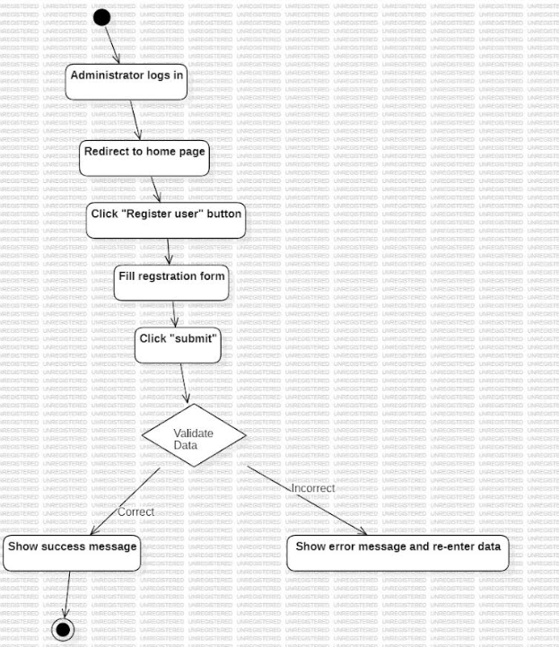

|  |  |
| --- | --- |
| **Name** | **US_03** Update or Delete Users (FR_03) |
| **Summary** | Administrator logs in the system and updates/deletes other Users of FMS |
| **Dependency** | This use case depends on the successful completion of the login use case (US_02). The Admin must be authenticated before accessing the user registration functionality. |
| **Actors** | Administrator (Primary actor) |
| **Description of**  **the Main**  **Sequence** | * Administrator logs into the system. * Administrator navigates to the “User Management” section. * The system displays a table of all registered users. * Administrator selects a specific user. * Administrator chooses either:  a. “Update” – A form appears with the current user’s details pre-filled.   i. Admin modifies the data and submits the form.   ii. System validates the data and updates the user in the database.   iii. A confirmation message is shown.  b. “Delete” – The system asks for confirmation.   i. Upon confirmation, the user is deleted from the system.   ii. A success message is shown. |
| **Preconditions** | Administrator must be logged into the system with a valid account and have user management privileges. |
| **Description of**  **the Alternative**  **Sequence** | • If the selected user does not exist (e.g., already deleted by another admin), an error message is displayed.  • If the admin cancels the delete/update operation, the system returns to the user list without applying any changes. |
| **Non functional**  **requirements** | • Updates and deletions must be recorded in an activity log. • The update form must validate all fields before submission. • Deletion must prompt a confirmation to prevent accidental data loss. • The user management page must load within 300ms. |
| **Post Conditions** | The selected user account is either updated with new data or removed from the system. The change is recorded in the audit log. |

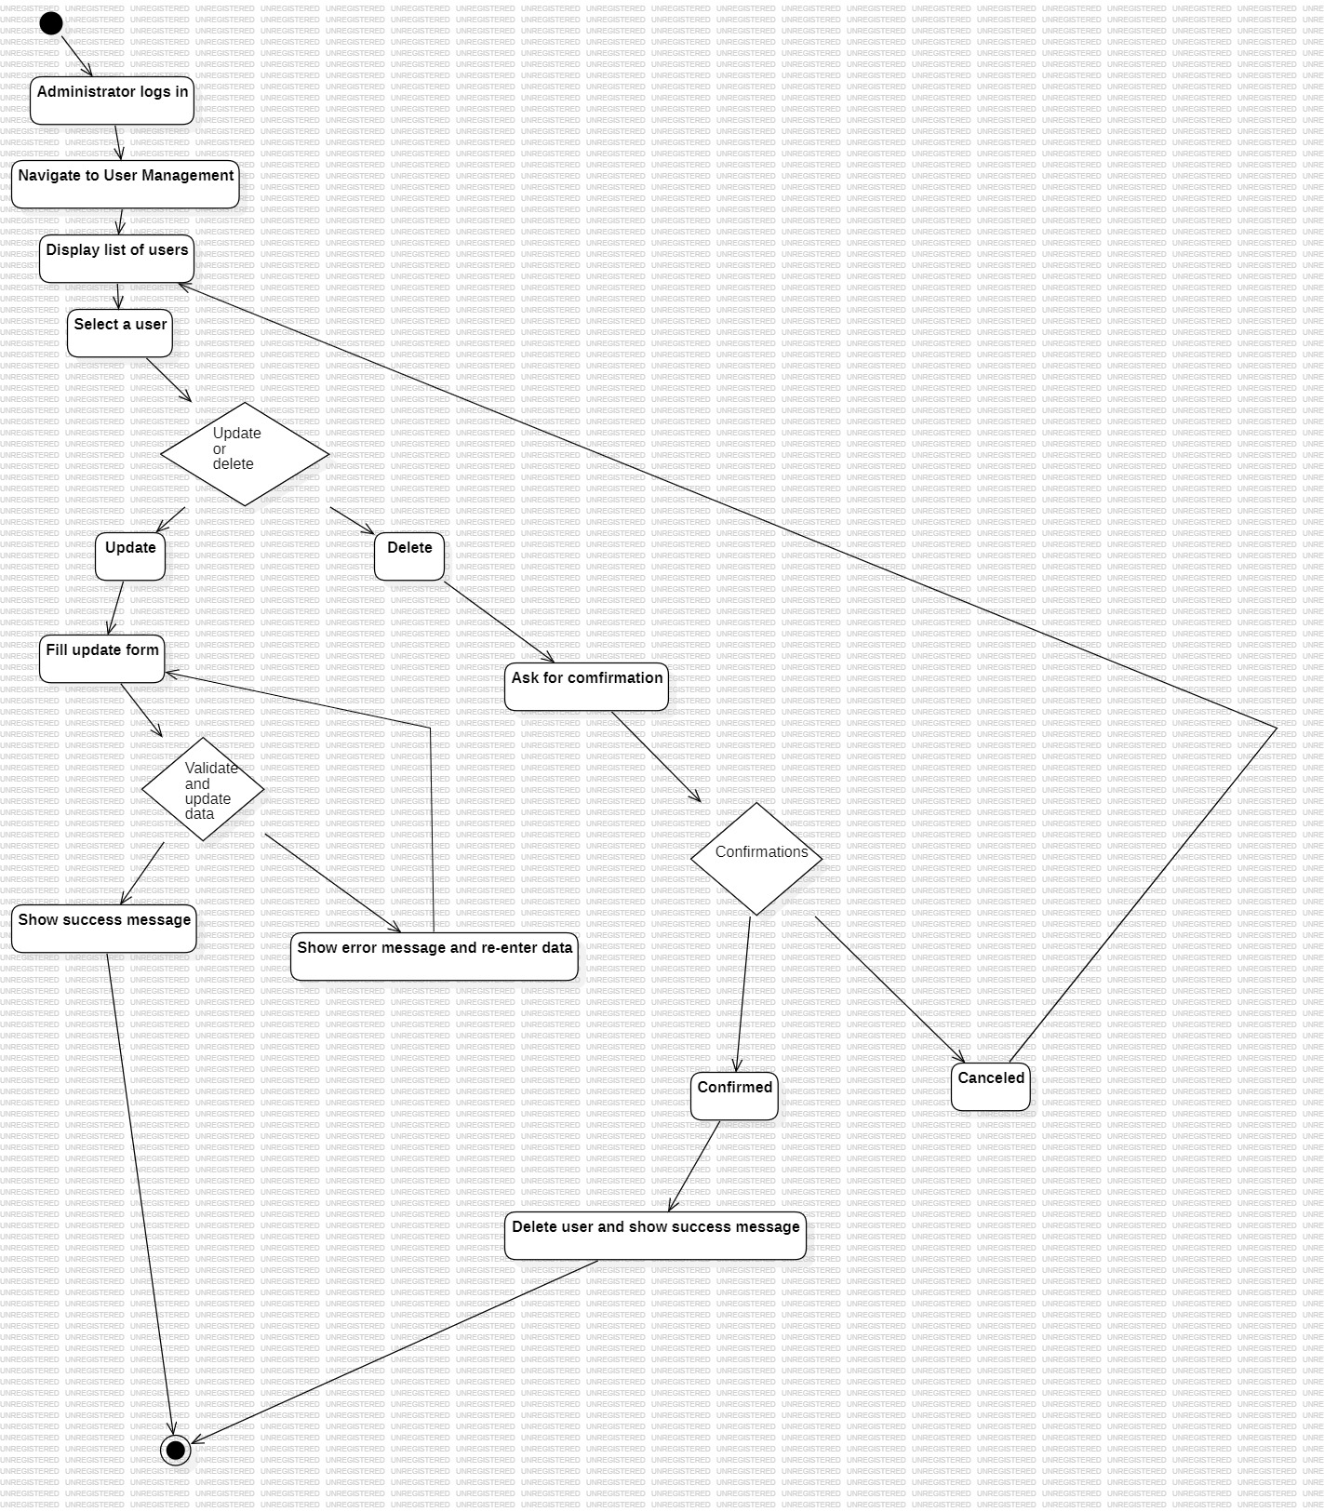

|  |  |
| --- | --- |
| **Name** | **US_02** User Login |
| **Summary** | The user enters the system by entering valid credentials |
| **Dependency** | US_01 |
| **Actors** | All Users (Administrator, CFO, HR, Sales Agent, Operations Manager, Manufacturer Employee) |
| **Description of**  **the Main**  **Sequence** | 1. According to the selected department, user is redirected to the login page where he/she inserts his credentials.  2. If username and password are:  a. correctly inserted, user successfully logs in.  i. user is directed to his/her home page.  b. not right, user fails to log in.  i. user is directed to the login page and all the above-mentioned steps are repeated until user is successfully logged in. |
| **Preconditions** | The user who loges in, must have first an existing account, with a specific username and password |
| **Description of**  **the Alternative**  **Sequence** | -If the system detects multiple failed login attempts, it temporarily disables the account for security purposes.  -User must wait a period or contact Admin to reactivate access |
| **Non functional**  **requirements** | • The login page must load within 100ms.  • Passwords must be encrypted.  • Login fields must be validated for empty or invalid inputs.  • CAPTCHA may be added after 3 failed attempts |
| **Post Conditions** | The user gains access to the features and functionalities of the system based on their role. |

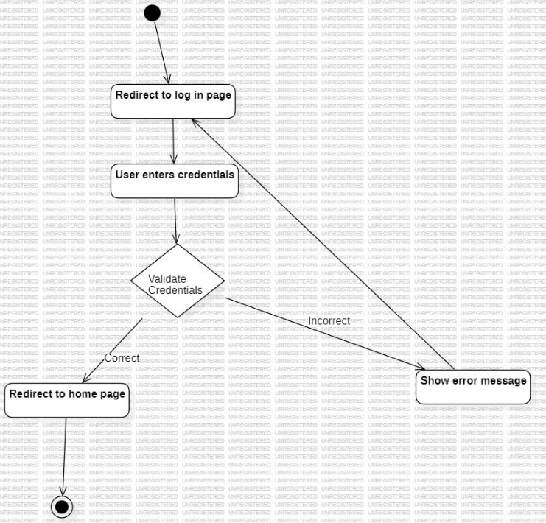

|  |  |
| --- | --- |
| **Name** | **US_04 Administrator**  **Performs System Backup and Restore (FR_02)** |
| **Summary** | The Administrator performs a backup or restores the system data in case of failure or as part of routine maintenance. |
| **Dependency** | US_02 |
| **Actors** | Primary actor: Administrator |
| **Description of**  **the Main**  **Sequence** | - Administrator logs in following US_02.  - From the home page, the Administrator selects the “System Settings” or “Backup & Restore” section.  - Administrator chooses one of the options:  a. “Create Backup”  b. “Restore System”  - If **Create Backup** is selected:  a. System displays current backup status and storage location.  b. Admin confirms and initiates the backup.  c. A success message appears once the backup is completed.  - If **Restore System** is selected:  a. System prompts for selection of a backup file.  b. Admin confirms restoration.  c. System restores the data and displays a confirmation message. |
| **Preconditions** | • Administrator must be logged into the system. • System must have backup privileges enabled. |
| **Description of**  **the Alternative**  **Sequence** | If storage is full or the selected backup is corrupted: • System displays an error message. • Admin is prompted to retry with another storage location or backup file. |
| **Non functional**  **requirements** | • The backup and restore module must load in ≤ 500ms.  • Backup file must be compressed to save space.  • Backup files must be encrypted.  • Operations should log events for audit tracking |
| **Post Conditions** | • A new backup is created and securely stored • Or the system is restored to a previous stable state |

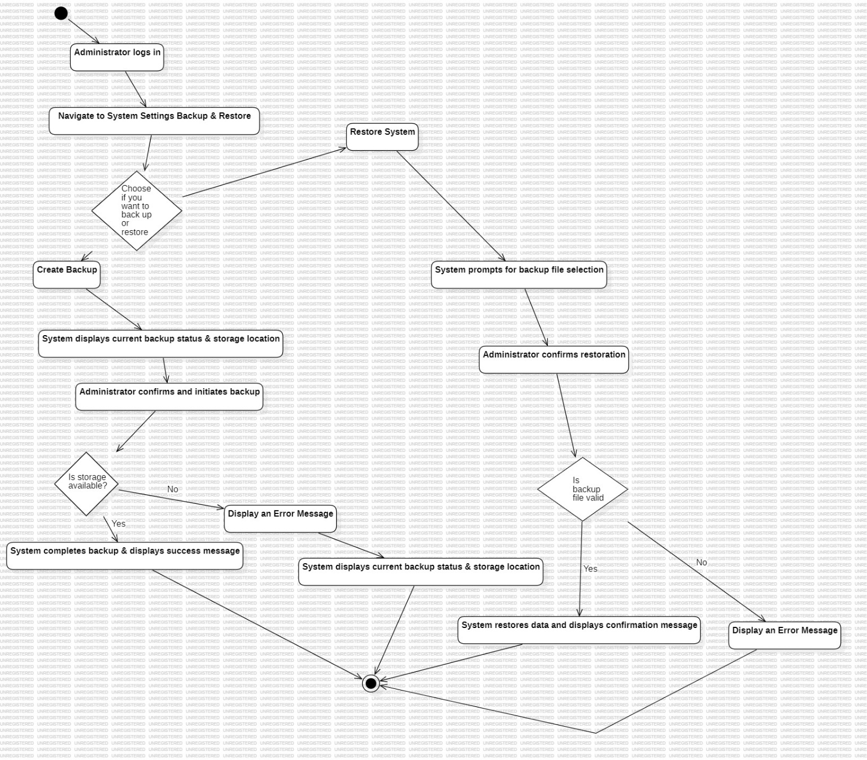

|  |  |
| --- | --- |
| **Name** | **US_05 Customer Registration & Edit** (FR_21) |
| **Summary** | Sales Agent register a customer with needed information |
| **Dependency** | US_01,US_02 |
| **Actors** | Sales Agent (Primary Actor) |
| **Description of**  **the Main**  **Sequence** | 1. Sales manager logs in following the steps of US_01.  2. The “Customers” section is selected.  3. After a table with previous customers is displayed, sales agent may select the “Add new Customer” button.  4. Sales manager fills in the form displayed to gather customer data.  5. The “Submit” button is selected.  6. The data inserted follows a validation process.  7. If data are:  a. correctly inserted, the message “Customer is successfully registered” is displayed and data are automatically registered in the database.  i. Sales manager is directed to the table of customers.  b. incorrect, alert messages for the specific errors in the fields of the form are displayed.  i. Sales manager corrects the fields then resubmits the data. Steps 6 and 7 are repeated until 7/a is fulfilled.  8. If successfully registered, will be shown in customer list view section |
| **Preconditions** | Sales agent must be logged in into the system |
| **Description of**  **the Alternative**  **Sequence** | If customer data already exists (duplicate), system shows a warning and prevents duplicate registration. |
| **Non functional**  **requirements** | • The registration form must load within 300ms.  • Input fields must be validated for correct formats (e.g., phone number, email).  • The system should encrypt sensitive customer data before storing. |
| **Post Conditions** | Customer record is created and available in the system’s customer list for future operations |

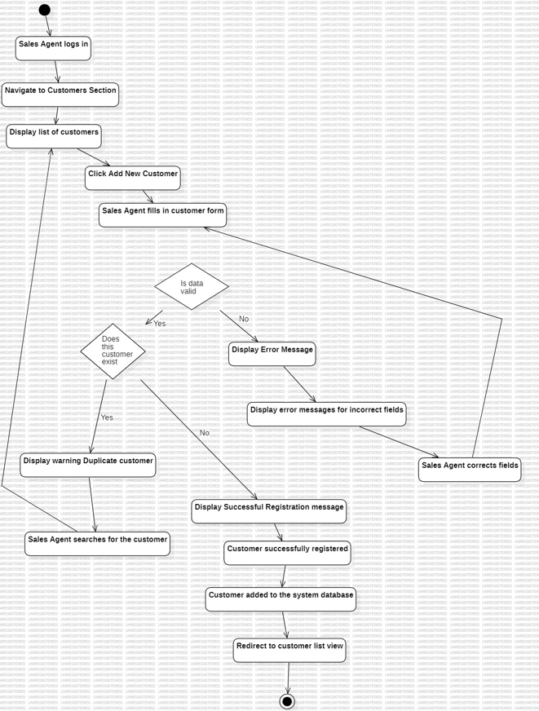

|  |  |
| --- | --- |
| **Name** | **US_06 Generate Reports(FR_04)** |
| **Summary** | Administrator generates weekly or monthly reports that provide insights into various company operations. |
| **Dependency** | US_02 |
| **Actors** | Administrator (Primary Actor)  CFO & Sales Agent: secondary ones |
| **Description of**  **the Main**  **Sequence** | - Administrator logs into the system.  - From the dashboard, the Administrator navigates to the “Reports” section.  - The system displays report options: Weekly, Monthly, and Custom Range.  - Administrator selects the desired report period and type (e.g., financial, employee performance, sales statistics).  - System processes and generates the requested report.  - The report is displayed in tabular and graphical format.  - Administrator may export the report as a PDF or Excel file. |
| **Preconditions** | Administrator must be logged in into the system |
| **Description of**  **the Alternative**  **Sequence** | 1. If no data is available for the selected time range, a message is shown: “No data available for this period.”  2.If the report fails to generate due to a system error, the admin is advised to retry or contact support. |
| **Non functional**  **requirements** | • Reports must be generated in under 2 seconds for recent data. • Graphical charts should render clearly and adapt to screen size. • Exported reports must preserve formatting. • The reporting module must support secure access. |
| **Post Conditions** | The selected report is generated, displayed, and optionally downloaded or printed. Insights from reports support decision-making. |

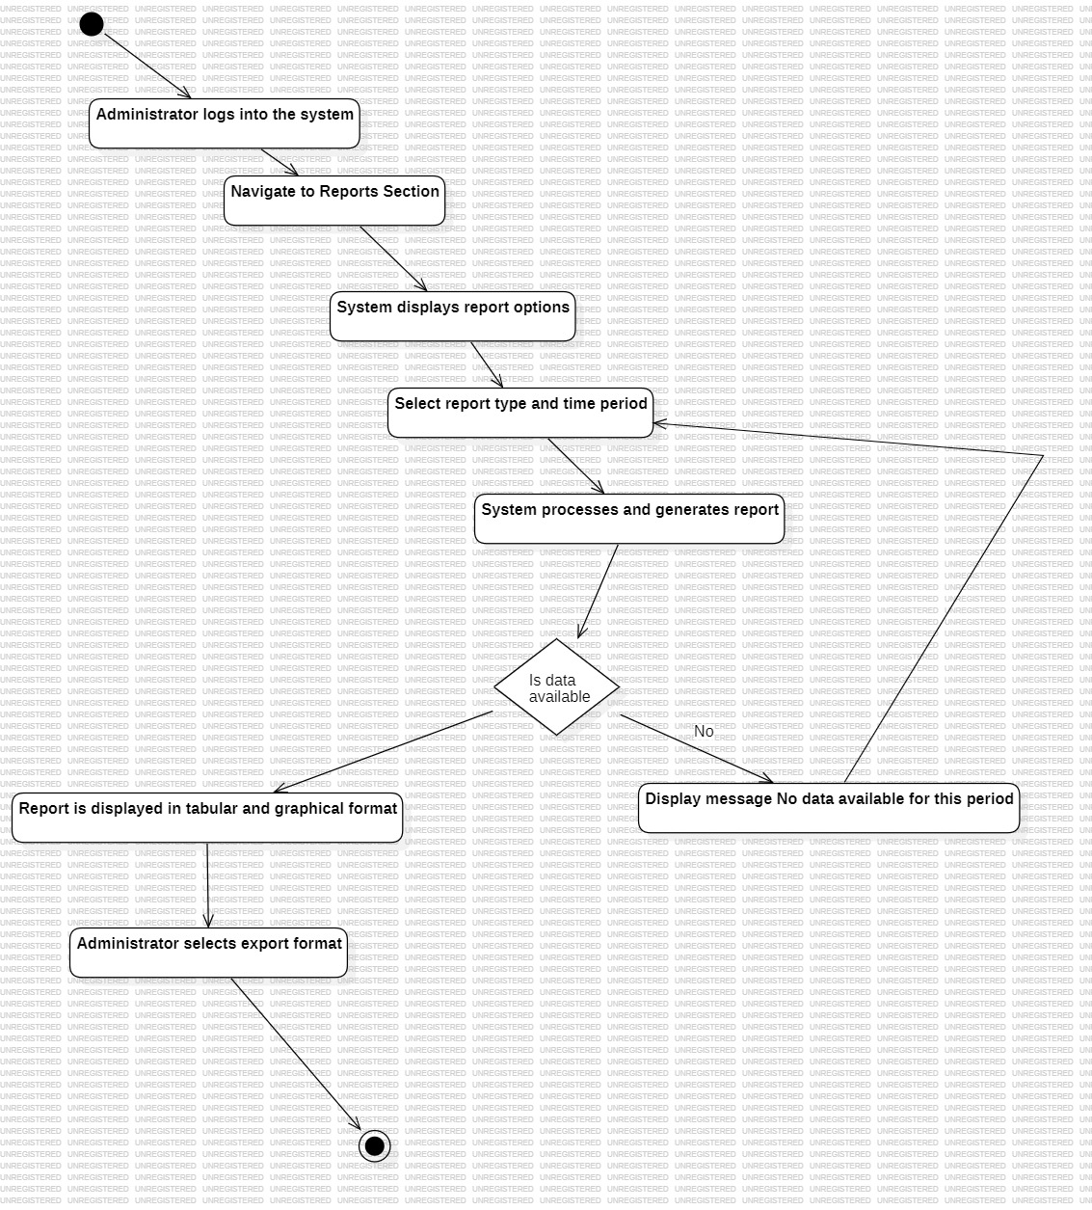

|  |  |
| --- | --- |
| **Name** | **US_07 Track pending payments (FR_06)** |
| **Summary** | CFO monitors pending customer payments and sends reminders to ensure timely payment collection. |
| **Dependency** | US_02 (User Login), US_21 (Invoice Generation) – CFO must be logged in and invoices must exist. |
| **Actors** | |  | | --- | |  | | Chief Financial Officer (CFO – Primary Actor) | |  |  | | --- | |  | |
| **Description of**  **the Main**  **Sequence** | 1. CFO logs into the system using valid credentials.  2. CFO navigates to the “Invoices” or “Accounts Receivable” section.  3. The system displays a list of all customer invoices, highlighting overdue or pending payments.  4. CFO filters or sorts invoices by due date or payment status.  5. CFO selects an invoice or a group of invoices.  6. CFO clicks “Send Reminder” button.  7. System generates and sends payment reminder emails to the respective customers.  8. System logs the reminder activity. |
| **Preconditions** | • Invoices must have been previously generated and assigned due dates. • CFO must be authenticated with appropriate financial access. |
| **Description of**  **the Alternative**  **Sequence** | -If a customer email is missing or invalid, the system will show an error and prevent reminder from being sent.  -If no invoices are pending, a message such as “All payments are up to date” is displayed. |
| **Non functional**  **requirements** | • Reminder generation must be completed in ≤ 2 seconds. • All actions must be logged for auditing purposes. • Reminder messages must be customizable and template-driven. |
| **Post Conditions** | Reminders are sent to customers with pending payments, and activity is logged. CFO can track which customers were notified. |

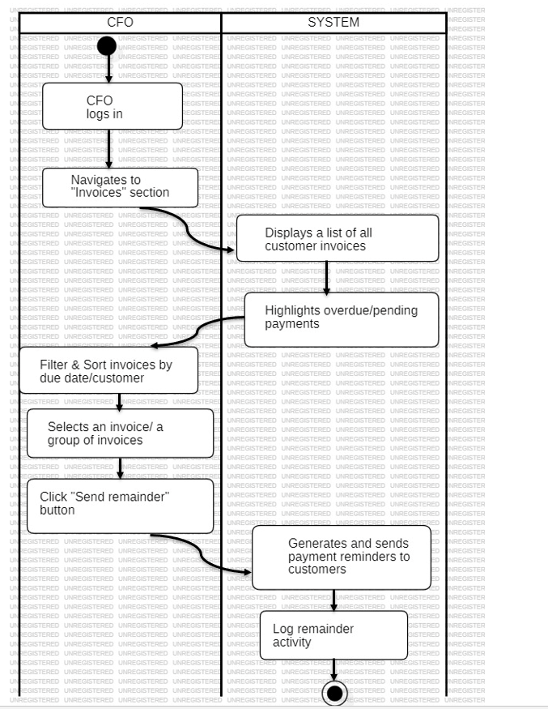

|  |  |
| --- | --- |
| **Name** | **US_08 Calculate delivery dates (FR_05)** |
| **Summary** | The system automatically calculates an estimated delivery date based on production time and the delivery schedule. |
| **Dependency** | US_21 (Order Creation) and production schedule must be set; delivery configurations must be predefined. |
| **Actors** | |  | | --- | |  |   Sales Agent, System (automated actor) |
| **Description of**  **the Main**  **Sequence** | 1. Sales Agent logs into the system.  2. A customer places an order or an order is being finalized.  3. The system retrieves:  a. Expected production time for the ordered item(s).  b. Delivery schedules for the destination.  4. The system performs an automatic calculation of the earliest available delivery window.  5. The calculated delivery date is displayed to the Sales Agent and included in the order summary.  6. The agent confirms and proceeds with the order. |
| **Preconditions** | • The order must contain valid items and quantities. • Production time and delivery schedules must be set in the system. |
| **Description of**  **the Alternative**  **Sequence** | If delivery schedules are not configured or production time is unavailable, the system notifies the agent: “Estimated delivery date cannot be calculated – please check configuration |
| **Non functional**  **requirements** | • Delivery date calculation must occur in ≤ 2 seconds. • The algorithm must consider public holidays and weekends (configurable). • The estimated date must appear clearly in the UI and exported invoice. |
| **Post Conditions** | An estimated delivery date is shown and linked to the customer’s order for future tracking and planning. |

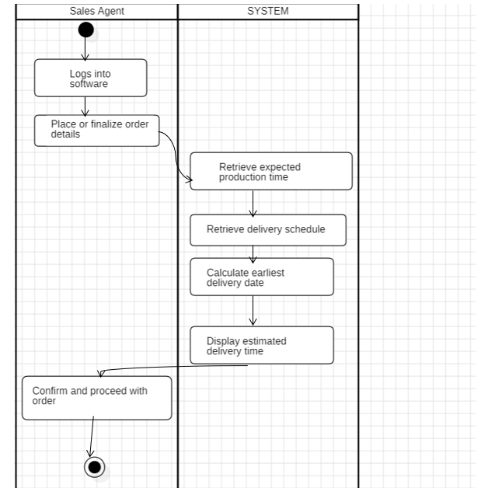

|  |  |
| --- | --- |
| **Name** | **US_09 Add suppliers and categories of products they supply (FR_12)** |
| **Summary** | CFO registers new suppliers and assigns them to raw material categories, including resource details and pricing. |
| **Dependency** | US_02 (User Login) – CFO must be authenticated before managing suppliers. |
| **Actors** | |  | | --- | |  |   CFO(primary actor), System(automated actor) |
| **Description of**  **the Main**  **Sequence** | 1. CFO logs into the system.  2. CFO navigates to the “Suppliers” section in the procurement or inventory module.  3. CFO selects “Add New Supplier.”  4. The system displays a supplier registration form.  5. CFO enters supplier information:  • Name, contact details, delivery terms, pricing tiers, etc.  6. CFO selects or creates a raw material category (e.g., wood, metal, fabric) that the supplier provides.  7. CFO submits the form.  8. The system validates the information and saves the supplier to the database.  9. A confirmation message is shown. |
| **Preconditions** | • CFO must be logged in with supplier management rights. • Raw material categories must be defined or added during the process. |
| **Description of**  **the Alternative**  **Sequence** | - If the supplier already exists (duplicate), system will show a warning.  - If mandatory fields are missing, validation will highlight the errors and prevent submission. |
| **Non functional**  **requirements** | • Supplier registration must be completed in ≤ 3 seconds. • Supplier and category names must be validated to avoid duplicates. • System must support updating pricing information and historical prices over time. |
| **Post Conditions** | A new supplier is added and linked to specific raw material categories, enabling purchasing and inventory tracking. |

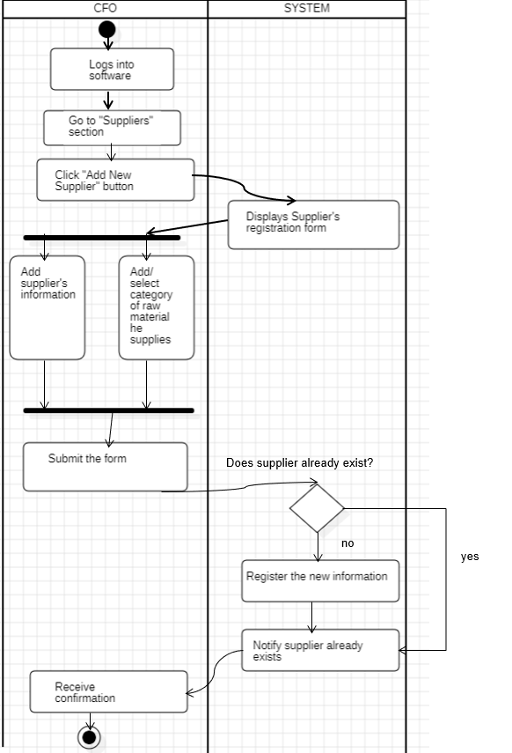

|  |  |
| --- | --- |
| **Name** | **US_10 Registering Expenses (FR_07)** |
| **Summary** | The CFO logs and categorizes every company expense into the system to maintain transparency and support budgeting. |
| **Dependency** | US_02, US_09 |
| **Actors** | |  | | --- | |  |   CFO(primary actor), System (automated) |
| **Description of**  **the Main**  **Sequence** | 1. CFO logs into the system.  2. CFO navigates to the “Expenses” module or section.  3. CFO clicks on “Register New Expense.”  4. A form appears requiring details such as:  • Expense type (e.g., raw materials, utilities, salaries, rent, maintenance)  • Amount  • Date  • Supplier or beneficiary  • Additional notes or attachments (e.g., invoices or receipts)  5. CFO fills out the form and clicks “Submit.”  6. The system validates the input and logs the expense into the database.  7. A confirmation message is displayed. |
| **Preconditions** | • CFO must have access to the finance module. • Expense categories must be predefined or created during the process. |
| **Description of**  **the Alternative**  **Sequence** | • If mandatory fields are missing, system alerts the CFO and prevents submission.  • If duplicate expense entries are detected (e.g., same invoice), a warning message is displayed. |
| **Non functional**  **requirements** | • Expense entry form must validate data types and prevent empty required fields. • Entry should not take more than 3 seconds. • System must auto-categorize recurring expenses. • All entries must be audit-logged. |
| **Post Conditions** | The expense is successfully saved into the system’s financial database, contributing to overall budget tracking and report generation. |

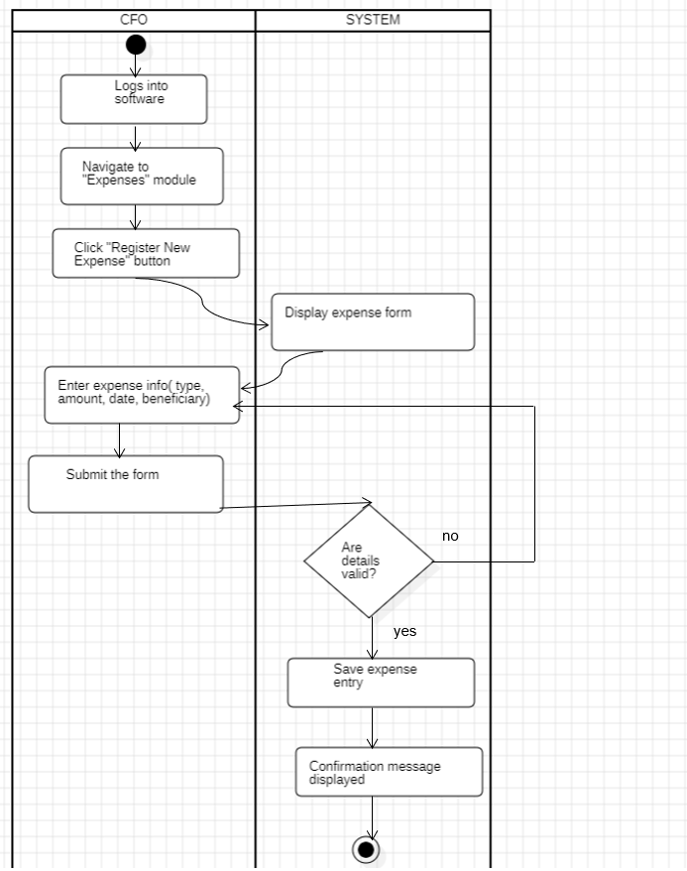

|  |  |
| --- | --- |
| **Name** | **US_11 Log Sale Transactions (FR_08)** |
| **Summary** | The CFO monitors and records each product sale made within the company. |
| **Dependency** | US_02, US_21, US_12 |
| **Actors** | |  | | --- | |  |   CFO(primary actor) |
| **Description of**  **the Main**  **Sequence** | 1.CFO logs into the system.  2.CFO navigates to the “Sales” or “Transactions” section.  3.The system displays completed sales transactions.  4.For each transaction, the system logs:   • Product name   • Quantity   • Customer details   • Payment method   • Date and time  5.CFO can view, filter, or export this log for reporting purposes. |
| **Preconditions** | Orders must have been placed and successfully completed by sales agents. |
| **Description of**  **the Alternative**  **Sequence** | 1. If no sales exist, the system shows “No recent sales.”  2. If logging fails, a backup method logs the transaction asynchronously. |
| **Non functional**  **requirements** | Transactions must be logged automatically and in real time. Data must be tamper-proof and exportable in secure formats. |
| **Post Conditions** | All sales transactions are logged and accessible for financial and auditing purposes. |

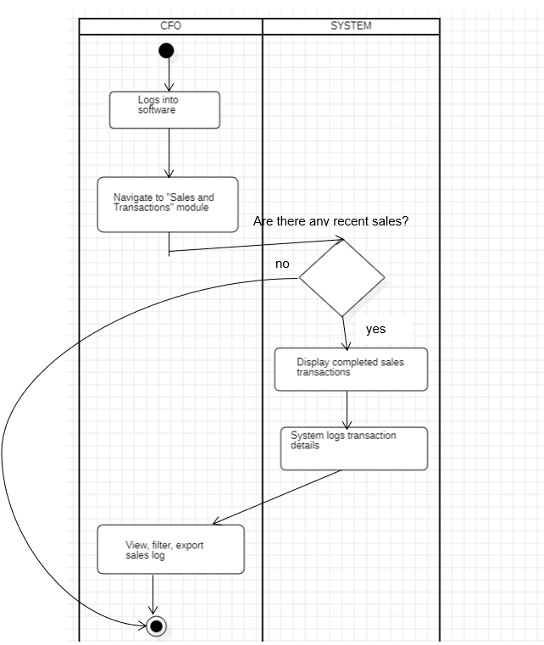

|  |  |
| --- | --- |
| **Name** | **US_12 Product Registering and categorization by type (FR_09, FR_10)** |
| **Summary** | The CFO registers a new product into the system, providing essential details and assigning a brand and category to organize inventory. |
| **Dependency** | US_02, |
| **Actors** | |  | | --- | |  |   CFO(primary actor) |
| **Description of**  **the Main**  **Sequence** | • CFO logs into the system.  • CFO navigates to the “Product Management” or “Inventory” module.  • CFO clicks the “Add New Product” button.  • A product registration form appears with fields for:  • Product Name  • Price  • Description  • Quantity  • Brand (select from existing or add new)  • Category (select from existing or add new)  • CFO selects or creates a **brand** and **category** to assign the product to.  • CFO submits the form.  • System validates the entries.  • If valid:  • Product is saved to the product catalog.  • A confirmation message is shown.  • If invalid:  • Errors are highlighted and CFO is prompted to correct them.  • The new product becomes available for sale in the system. |
| **Preconditions** | CFO must be logged in. At least one category or brand must exist or be created during the process. |
| **Description of**  **the Alternative**  **Sequence** | If brand or category selected does not exist, CFO can create it on the spot.  If a duplicate product name exists, the system will alert and suggest renaming or editing. |
| **Non functional**  **requirements** | The form must validate all inputs and prevent duplicate entries.  Brand and category dropdowns must be dynamically populated.  System must allow batch import for product creation in the future. |
| **Post Conditions** | The product is successfully saved, assigned a brand and category, and appears in the system as available for sales and inventory operations |

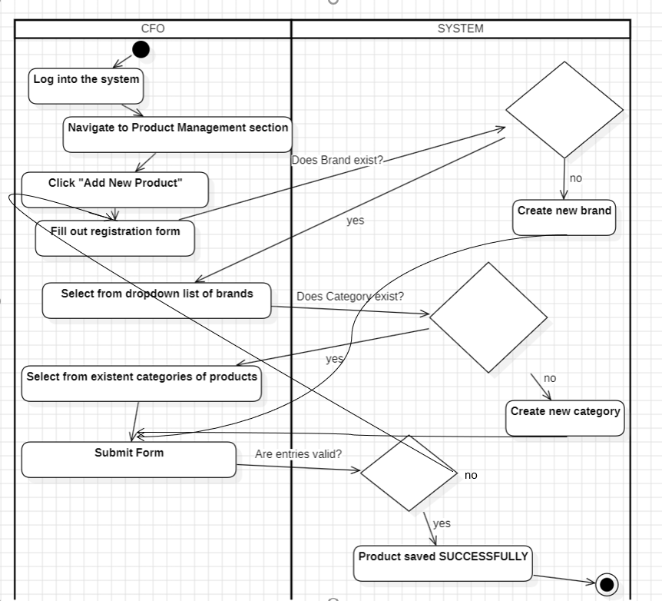

|  |  |  |
| --- | --- | --- |
| **Name** | | **US_13 – Initiate Salary Payments and Register Expenses** | | --- |   (FR_11) |
| **Summary** | The CFO initiates salary disbursements and records associated expenses including bonuses, deductions, and overtime. |
| **Dependency** | US_02, |
| **Actors** | |  | | --- | |  |   CFO(primary actor) |
| **Description of**  **the Main**  **Sequence** | 1. CFO logs into the system.  2. CFO accesses the “Finance” or “Payroll” module.  3. CFO selects the “Initiate Payment” option.  4. The system displays a payroll summary for the selected period.  5. CFO reviews each employee’s record, including:  • Base salary  • Bonuses  • Overtime  • Deductions  6. CFO confirms the data and initiates the payment process.  7. System records the disbursements in the financial database.  8. A confirmation message is displayed, and expenses are categorized. |
| **Preconditions** | Employee salary details must already be registered in the system. CFO must be authenticated and have permission to handle financial operations. |
| **Description of**  **the Alternative**  **Sequence** | If employee salary data is missing or outdated, system prompts CFO to update records.  If insufficient funds or technical errors occur, the system aborts payment and logs the error. |
| **Non functional**  **requirements** | The system must ensure secure transactions. All payments and adjustments must be logged for auditing |
| **Post Conditions** | Employee salaries are paid, and all related financial records are logged under appropriate expense categories for payroll and budgeting reports |

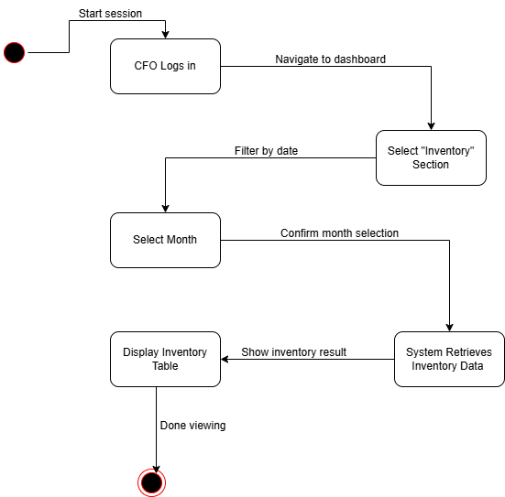

|  |  |
| --- | --- |
| **Name** | **US_14 – Manage Employee Records (FR_14)** |
| **Summary** | HR personnel can add, update, and remove employee information in the system, ensuring accurate records. |
| **Dependency** | US_02, US_01 |
| **Actors** | |  | | --- | |  |   HR(primary actor) |
| **Description of**  **the Main**  **Sequence** | 1. HR logs into the system.  2. HR navigates to the “Employee Management” module.  3. The system displays the list of current employees.  4. HR can perform one of the following actions:  a. **Add Employee**:   - Click “Add New Employee”   - Fill in details such as name, role, department, salary, employment type   - Submit the form  b. **Update Employee**:   - Select an employee   - Edit existing information (e.g., salary, role, department)   - Save changes  c. **Remove Employee**:   - Select an employee   - Click “Delete” and confirm the action  5. System validates the action and updates the database.  6. A confirmation message is shown. |
| **Preconditions** | • HR must be authenticated. • Departments and roles should be predefined or added during the process. |
| **Description of**  **the Alternative**  **Sequence** | 1.If mandatory fields are left blank:  the system will not allow submission and highlight missing data.  2.If trying to delete a protected or inactive employee:  system prompts for further confirmation or denies the action. |
| **Non functional**  **requirements** | • Input must be validated for format and completeness.  • All actions must be audit-logged for HR records. |
| **Post Conditions** | The employee records are updated, added, or removed from the system. Changes reflect across modules (e.g., payroll, department listings). |

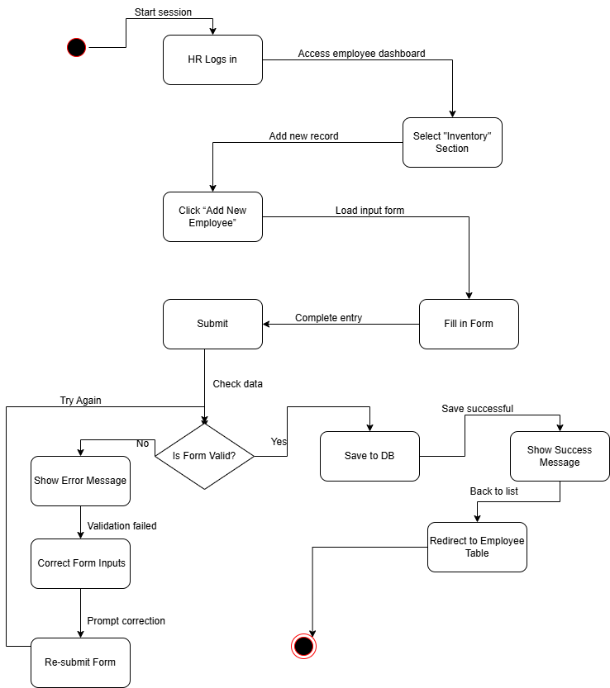

|  |  |
| --- | --- |
| **Name** | **US_15 – View Raw Materials and Stock Levels (FR_12)** |
| **Summary** | The CFO views real-time data on raw material stock levels, including quantity available, supplier details, and purchase history. |
| **Dependency** | US_02 |
| **Actors** | |  | | --- | |  |   CFO(primary actor) |
| **Description of**  **the Main**  **Sequence** | 1. CFO logs into the system.  2. CFO navigates to the “Raw Materials” or “Inventory” module.  3. The system displays a list of raw materials with the following details:  • Quantity available  • Supplier details  • Purchase history (e.g., order dates, quantities)  • Cost tracking and pricing information  4. CFO can filter or search for specific materials by name, category, or supplier.  5. The system updates data in real-time, reflecting current stock levels and supplier changes |
| **Preconditions** | CFO must be authenticated with inventory viewing rights.  Raw material and supplier data must be registered in the system. |
| **Description of**  **the Alternative**  **Sequence** | If no data is available for the selected raw material, the system displays: “No stock data available for this material.”  If the data is outdated or incomplete, the system prompts the CFO to verify with the responsible department. |
| **Non functional**  **requirements** | The user interface must be responsive, especially for filtering or searching large datasets. |
| **Post Conditions** | The CFO successfully views the most up-to-date data on raw material stock levels, suppliers, and costs, helping with purchasing and operational decisions |

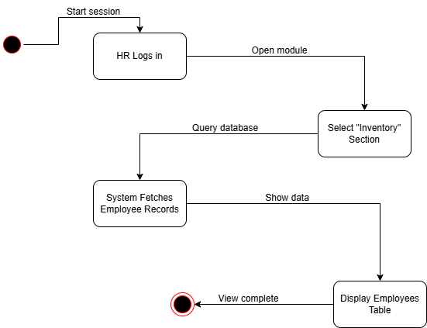

|  |  |
| --- | --- |
| **Name** | **US_16 – Calculate and Process Employee Salaries (FR_15)** |
| **Summary** | HR calculates and processes employee salaries, including deductions and bonus allocations. |
| **Dependency** | US_02 |
| **Actors** | |  | | --- | |  |   HR(primary actor) |
| **Description of**  **the Main**  **Sequence** | 1. HR logs into the system.  2. HR accesses the “Payroll Management” module.  3. HR selects the relevant pay period for salary calculations.  4. The system retrieves each employee's salary, deductions, and bonus details.  5. HR reviews the calculated salary for each employee, including:  • Base salary  • Deductions (taxes, benefits, etc.)  • Bonuses (if applicable)  6. HR can manually adjust any of the values if necessary (e.g., corrections for overtime or additional bonuses).  7.HR confirms the salary details and processes the payments.  8. The system generates a payroll report with all employees' processed salaries.  9. A confirmation message is displayed, and payment records are saved. |
| **Preconditions** | • Employee salary and deduction details must be registered in the system.  • HR must have permission to access payroll functions. |
| **Description of**  **the Alternative**  **Sequence** | 1. If salary data is missing or incomplete, the system will notify HR and prevent processing until corrected.  2. If manual adjustments are made, the system logs those adjustments for auditing purposes. |
| **Non functional**  **requirements** | The system must ensure that all calculations are accurate and comply with legal standards. |
| **Post Conditions** | Salaries are successfully processed, recorded in the financial database, and ready for disbursement.  Payroll reports are available for review and export. |

|  |  |
| --- | --- |
| **Name** | **US_17 – Assign and track training modules/programs for employees (FR_16)** |
| **Summary** | HR assigns and tracks training modules for employees based on their department or role. |
| **Dependency** | US_02 |
| **Actors** | |  | | --- | |  |   HR person(primary actor) |
| **Description of**  **the Main**  **Sequence** | 1. HR logs into the system.  2. HR navigates to the “Employee Training” module.  3. HR selects an employee or a department.  4. HR assigns a training module or program from a predefined list based on the employee’s role or department.  5. HR confirms the assignment and the system tracks the progress of the training.  6. The system sends reminders to employees about upcoming training sessions and deadlines.  7. HR can view training progress and completion status for each employee. |
| **Preconditions** | • Training modules must be predefined.  • Employee role and department must be correctly registered. |
| **Description of**  **the Alternative**  **Sequence** | 1.If training modules are unavailable:  HR is prompted to upload or create new content.  2.If an employee does not complete training on time:  the system sends an escalation reminder. |
| **Non functional**  **requirements** | • The system must track training completion in real-time.  • Notifications and reminders should be sent at least 2 days before the deadline. |
| **Post Conditions** | Training status for employees is updated in their records, contributing to employee development and performance evaluations. |

|  |  |
| --- | --- |
| **Name** | **US_18 – Employee of the Month Award for Best Sales Agent (FR_17)** |
| **Summary** | Each month, the system evaluates employee performance and automatically identifies the top-performing sales agent for recognition based on sales levels and working hours. |
| **Dependency** | US_14 |
| **Actors** | |  | | --- | |  |   HR person(primary actor), System(automated actor) |
| **Description of**  **the Main**  **Sequence** | At the end of each month, the system evaluates all sales data.  1. The system calculates the top-performing sales agent based on:  • Sales level  • Working hours and attendance  2. The system automatically identifies the top sales agent for the month.  3. HR reviews the list and confirms the selection.  4. The system awards the “Employee of the Month” title to the top sales agent and logs the achievement in the employee’s profile. |
| **Preconditions** | • Sales data must be complete and accurate. • Employee working hours and attendance must be recorded. |
| **Description of**  **the Alternative**  **Sequence** | If two or more employees have equal performance, the system uses secondary criteria (e.g., customer satisfaction or additional sales bonuses) to determine the winner. |
| **Non functional**  **requirements** | The selection process should be completed within 5 seconds after the end of the month.  • Awards and achievements must be logged and accessible in employee profiles. |
| **Post Conditions** | The best sales agent for the month is recognized, and their performance is recorded for future reference and bonuses. |

|  |  |
| --- | --- |
| **Name** | **US_19 – Process and Approve Employee Leave Requests (FR_18)** |
| **Summary** | Employees can request leave through the system, and HR will process and approve the requests accordingly. |
| **Dependency** | US_14 |
| **Actors** | |  | | --- | |  |   HR person(primary actor),  Administrator & Employee (secondary) |
| **Description of**  **the Main**  **Sequence** | 1.Employee logs into the system and navigates to the “Leave Request” section.  2.Employee selects the type of leave (e.g., sick leave, vacation) and the desired dates.  3. Employee submits the leave request for approval.  4. HR receives a notification about the pending leave request.  5. HR reviews the leave request, checking for overlapping leaves, available leave balance, and business requirements.  6. HR approves or denies the request.  7. The system sends an automated notification to the employee regarding the approval or denial. |
| **Preconditions** | • Employee must have an active account and sufficient leave balance. • HR must be authenticated with access to leave management. |
| **Description of**  **the Alternative**  **Sequence** | • If the leave balance is insufficient or if there is an overlap with other employees' requests, HR is notified, and the request may be denied.  • If the employee requests leave on short notice or during a critical business period, HR can escalate the decision for management review. |
| **Non functional**  **requirements** | • Automated notifications must be sent to both employee and HR. • The leave system should provide a clear overview of leave balance and approval status. |
| **Post Conditions** | The employee’s leave is either approved or denied, and the system is updated with the decision. HR has a record of all processed leave requests for future reference. |

|  |  |  |  |
| --- | --- | --- | --- |
| **Name** | | **US_20 – Add Sale Orders and Print Orders** | | --- |   **(FR_19)**   |  | | --- | |  | |
| **Summary** | Sales agents add sale orders to payment and print orders and receipts for customers. |
| **Dependency** | US_02 |
| **Actors** | |  | | --- | |  |   Sales Agent (Primary Actor) |
| **Description of**  **the Main**  **Sequence** | 1. Sales Agent logs into the system.  2. Sales Agent navigates to the “Order Management” section.  3. Sales Agent selects the “Add New Sale Order” option.  4. The system prompts the Sales Agent to enter the order details:  • Product(s)  • Quantity  • Price  • Customer information  5. Sales Agent confirms the order details.  6. The system processes the order and records it in the database.  7. Sales Agent generates an order receipt for the customer.  8. Sales Agent prints or emails the receipt to the customer. |
| **Preconditions** | • Sales Agent must have the correct product details and pricing.  • Sales Agent must be authenticated and authorized to process orders |
| **Description of**  **the Alternative**  **Sequence** | * + - 1. If any required fields are missing (e.g., product or customer information):   the system will prompt for corrections before proceeding |
| **Non functional**  **requirements** | • The system should process order data and generate receipts within ≤ 2 seconds. • Receipts should be printable and exportable in PDF format |
| **Post Conditions** | The sale order is successfully recorded, and a receipt is generated and provided to the customer. |

|  |  |  |
| --- | --- | --- |
| **Name** | **US_21 – View Sales Reports (FR_20)**   |  | | --- | |  | |
| **Summary** | Sales agents can view performance reports to analyze sales and adjust strategies. |
| **Dependency** | US_02 |
| **Actors** | |  | | --- | |  |   Sales Agent (Primary Actor) |
| **Description of**  **the Main**  **Sequence** | 1. Sales Agent logs into the system.  2. Sales Agent navigates to the “Sales Reports” section.  3. The system displays various sales reports, including:  • Daily sales  • Monthly sales  • Product performance  • Customer statistics  4. Sales Agent can filter reports by date range, product, or sales territory.  5. The system generates the requested report based on the filter parameters.  6. Sales Agent can view the report data or export it to PDF or Excel format. |
| **Preconditions** | Sales Agent must have completed sales transactions recorded in the system. Reports must be generated based on available sales data. |
| **Description of**  **the Alternative**  **Sequence** | 1. If no sales data is available for the selected period:  the system will display a message: “No data available for the selected period.” |
| **Non functional**  **requirements** | - |
| **Post Conditions** | The Sales Agent can analyze the performance data to adjust sales strategies. The report is accessible for review or export. |

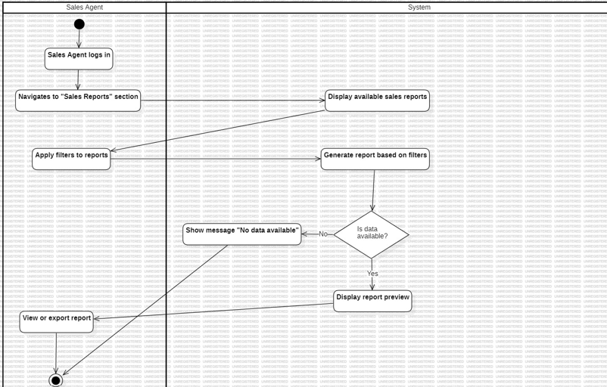

|  |  |
| --- | --- |
| **Name** | **US_22 – Apply Discounts or Promotional Codes (FR_22)** |
| **Summary** | Sales agents can apply discounts or promotional codes during the checkout process to facilitate promotional campaigns. |
| **Dependency** | US_02 (User Login), US_20 (Order Creation) – Sales agent must be logged in and have an active order to apply discounts. |
| **Actors** | |  | | --- | |  |   Sales Agent (Primary Actor) |
| **Description of**  **the Main**  **Sequence** | 1. Sales Agent logs into the system.  2. Sales Agent creates or accesses an active sale order (from US_20).  3. The system prompts for promotional code or discount at the checkout stage.  4. Sales Agent enters a system-approved promotional code or selects a discount.  5. The system validates the code or discount.  • If valid, the system applies the discount to the order total.  • If invalid, the system displays an error message.  6. The system updates the order total and displays the new price with the discount applied.  7. Sales Agent confirms the total price and completes the sale. |
| **Preconditions** | • Sales Agent must have permission to apply discounts or codes. • Promotional codes or discounts must be predefined and valid for use. |
| **Description of**  **the Alternative**  **Sequence** | 1. If the discount code is expired or invalid, the system will show: “This promotional code is invalid or expired.”  2. If the applied discount exceeds the allowed amount, the system prompts the Sales Agent to adjust the discount. |
| **Non functional**  **requirements** | The system must display the original and new price with the discount clearly marked |
| **Post Conditions** | The discount is successfully applied, and the updated total is recorded in the system for the sale. |

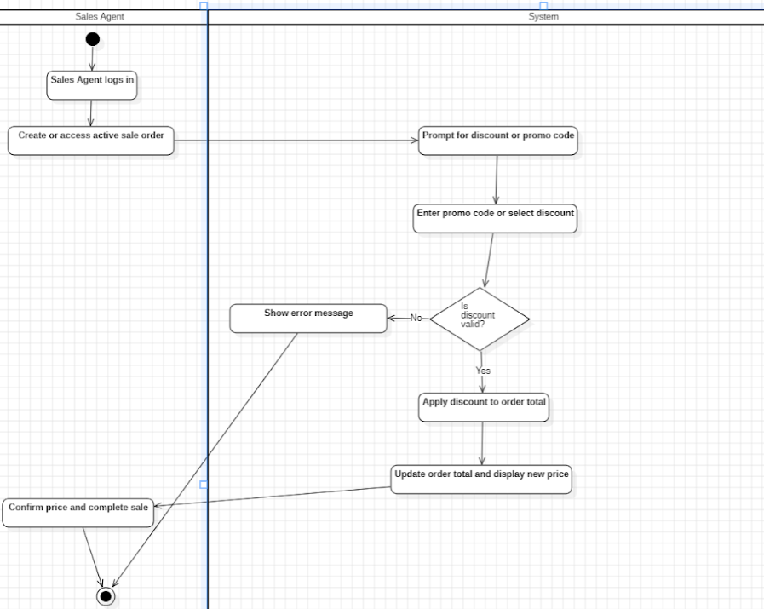

|  |  |
| --- | --- |
| **Name** | **US_23 – Search and Filter Customer Data (FR_23)** |
| **Summary** | Sales agents use the system to efficiently search and filter customer records based on specific criteria. |
| **Dependency** | US_02 (User Login) – Sales Agent must be logged into the system. |
| **Actors** | Sales Agent (Primary Actor) |
| **Description of the Main Sequence** | * Sales Agent logs into the system. * Sales Agent navigates to the “Customer Management” module. * The system displays a table/list of all registered customers. * Sales Agent enters a search query (e.g., name, phone number, email, purchase history). * The system filters and displays matching customer profiles in real-time. * Sales Agent can apply additional filters such as: * • Date of registration * • Purchase frequency * • Location * Sales Agent clicks on a customer to view full profile or initiate actions (e.g., update, order). |
| **Preconditions** | Customer data must already be registered in the system.  Sales Agent must have access to the customer module. |
| **Description of the Alternative Sequence** | * If no customers match the search, the system displays: “No matching customers found.” * If search input is invalid (e.g., symbols in a phone number), system prompts for correction. |
| **Non-functional Requirements** | Search must be case-insensitive and support partial matches.  Filtering options should be dynamic and customizable. |
| **Post Conditions** | The Sales Agent successfully views a refined list of customers and may proceed with further actions such as updating data, placing an order, or reviewing history. |

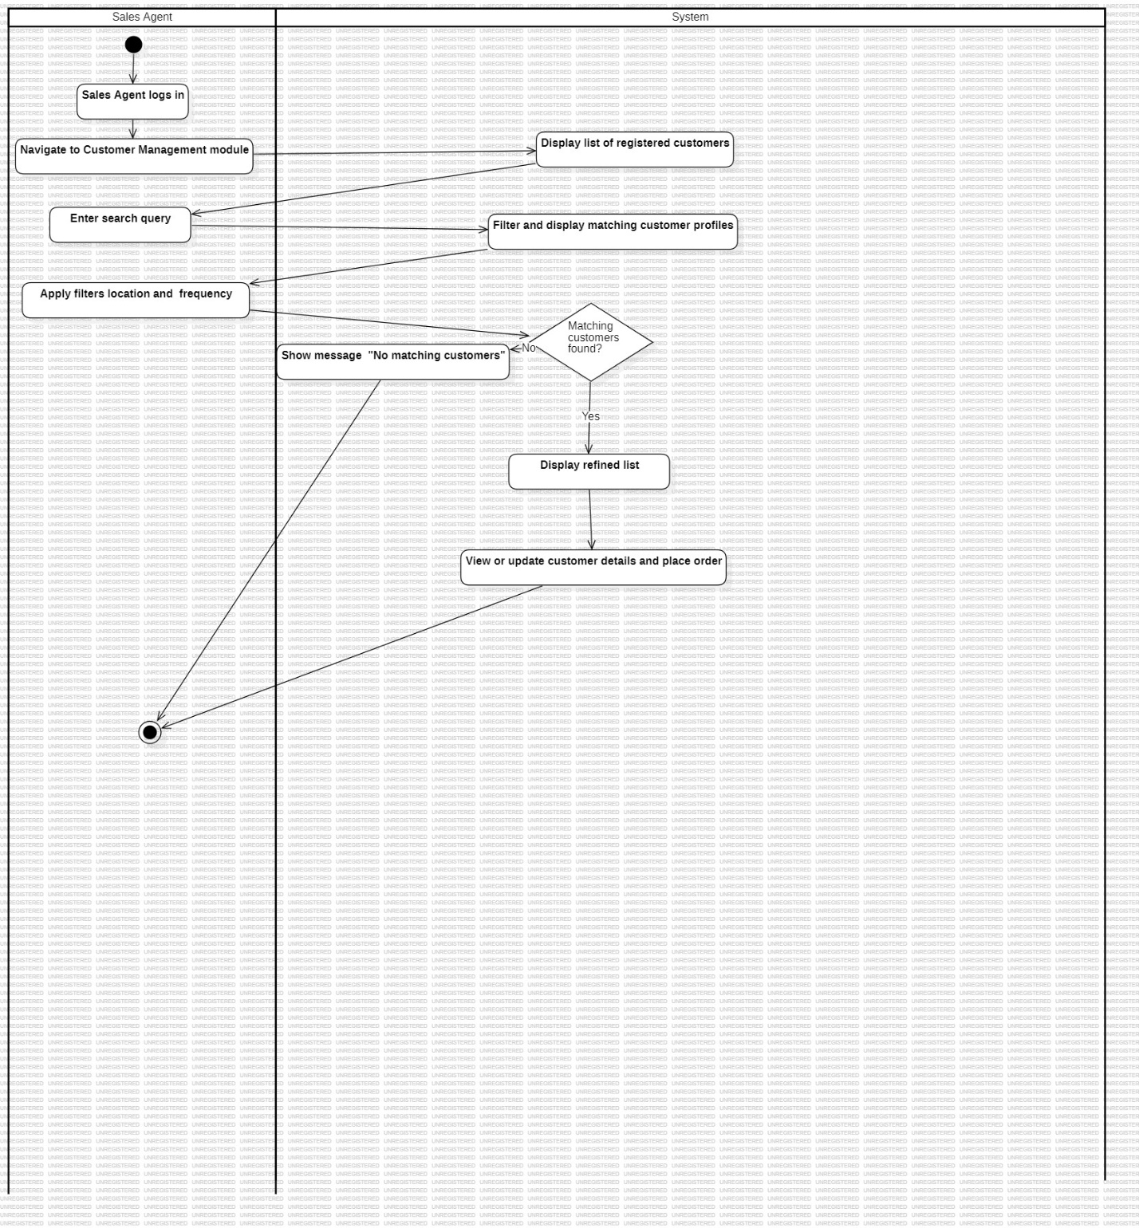

|  |  |
| --- | --- |
| **Name** | **US_24 – Add Raw Materials (FR_24)** |
| **Summary** | Operations Manager registers new raw materials used in the manufacturing process, such as wood, textiles, and metal. |
| **Dependency** | US_02 (User Login) – Operations Manager must be logged in to access material management. |
| **Actors** | Operations Manager (Primary Actor) |
| **Description of the Main Sequence** | * Operations Manager logs into the system. * Operations Manager navigates to the “Materials” or “Raw Materials” section. * The system displays the list of currently registered raw materials. * Operations Manager clicks on “Add New Material.” * A form appears requesting: * Material Name (e.g., Wood, Metal, Fabric) * Category (e.g., Raw Material, Finished Material) * Unit of Measure (e.g., kg, meters, pieces) * Supplier information (if applicable) * Operations Manager enters the material details and submits the form. * The system validates the data. * If valid, the material is added to the database. * A confirmation message is displayed. |
| **Preconditions** | Operations Manager must be authenticated.  Supplier and material categories must be predefined in the system |
| **Description of the Alternative Sequence** | * If mandatory fields are left blank, the system will highlight the missing fields and prompt the Operations Manager to correct them. * If the material already exists, a warning will be shown to prevent duplication. |
| **Non-functional Requirements** | Input fields must support data validation to ensure correct information is entered (e.g., valid units).  System should support batch uploading of materials if required. |
| **Post Conditions** | The raw material is successfully added to the system, becoming available for use in production planning and inventory management. |

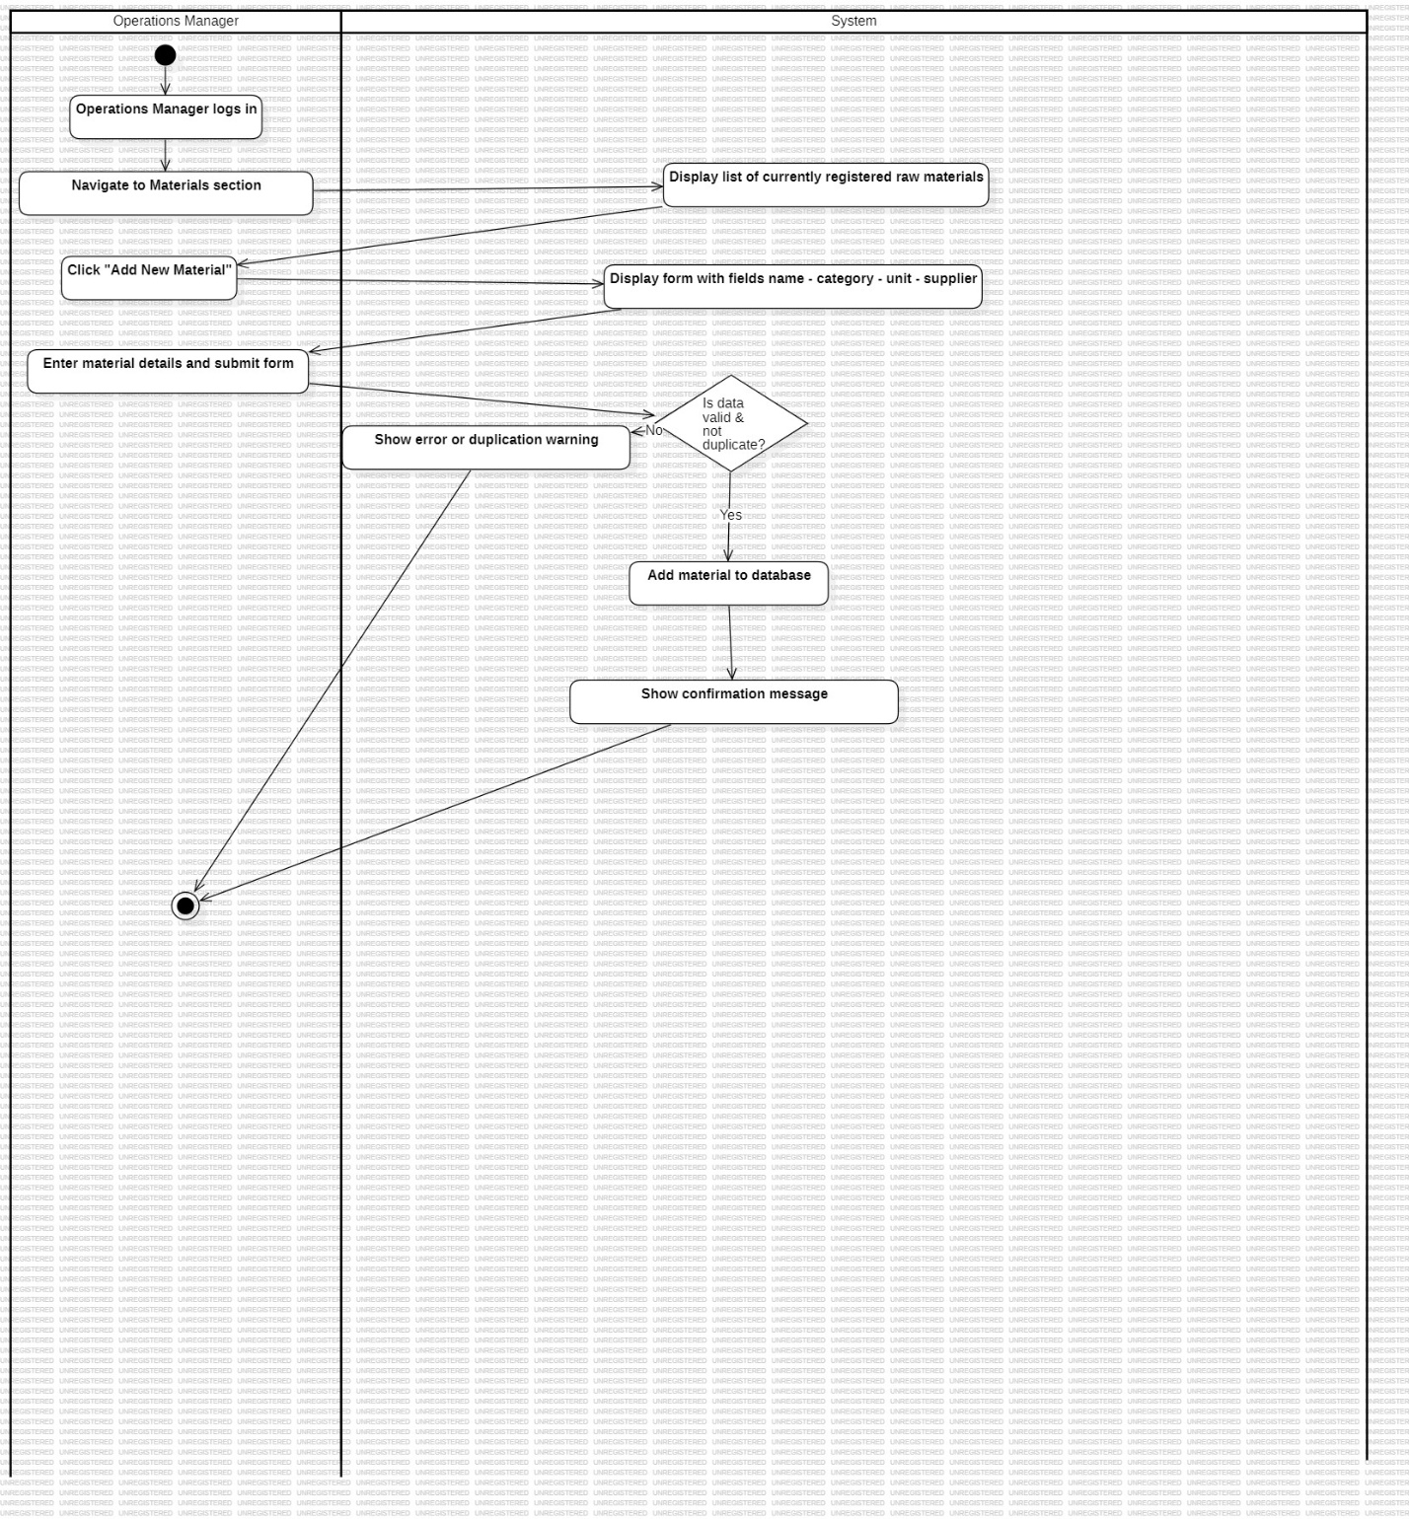

|  |  |
| --- | --- |
| **Name** | **US_25 – View and Access Labor Cost Data (FR_25)** |
| **Summary** | Operations Manager will view and access labor expenses data, which will be integrated into financial reports. |
| **Dependency** | US_02 (User Login) – Operations Manager must be logged in to access the labor cost module. |
| **Actors** | Operations Manager (Primary Actor) |
| **Description of the Main Sequence** | * Operations Manager logs into the system. * Operations Manager navigates to the “Labor Costs” or “Financial Reports” section. * The system displays labor cost data, including employee wages, overtime, and other labor-related expenses. * Operations Manager can view cost breakdowns by department, period, or employee. * Operations Manager may filter or search specific labor costs by criteria such as department or date range. * The system integrates labor expenses into the financial report, making them available for analysis. |
| **Preconditions** | Labor data must be already recorded in the system.  Operations Manager must have access to financial or labor cost data. |
| **Description of the Alternative Sequence** | * If no labor data is available for the selected period, the system displays: "No labor cost data available for this period." * If an invalid filter is applied, the system prompts for correction or reconfiguration. |
| **Non-functional Requirements** | Reports must be accurate, and any discrepancies should trigger an alert.  Data should be easily exportable to PDF/Excel formats for further analysis. |
| **Post Conditions** | The Operations Manager can view detailed labor cost information, which is integrated into financial reports for future budgeting and cost analysis. |

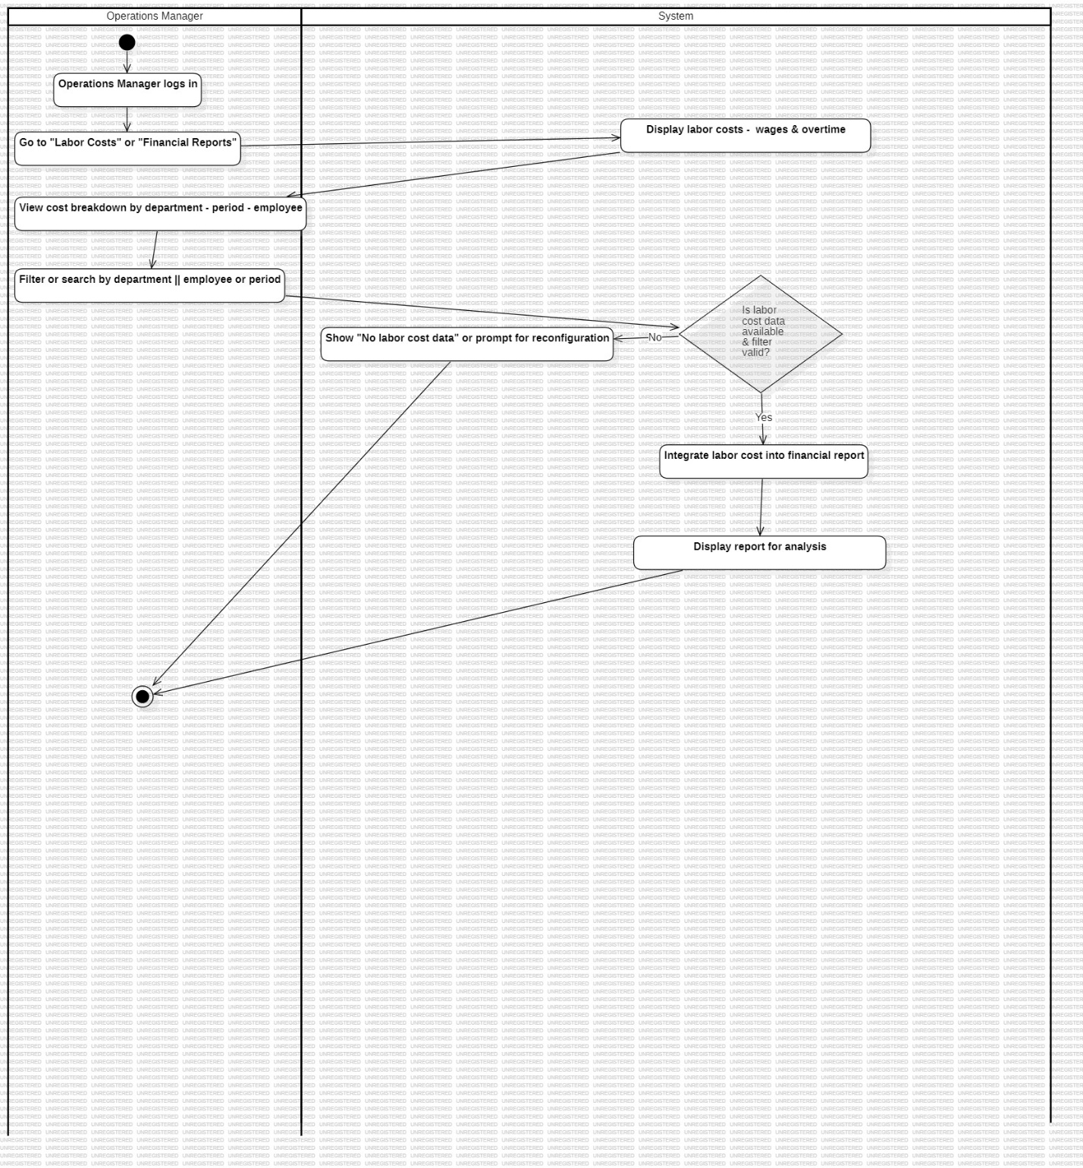

|  |  |
| --- | --- |
| **Name** | **US_26 – Maintain Assets (FR_26)** |
| **Summary** | Operations manager registers and maintains assets, including machinery, with detailed records and preventive maintenance planning. |
| **Dependency** | US_02 (User Login) – Operations Manager must be logged in to access asset management. |
| **Actors** | Operations Manager (Primary Actor) |
| **Description of the Main Sequence** | * Operations Manager logs into the system. * Operations Manager navigates to the “Asset Management” module. * The system displays a list of all registered assets (e.g., machinery). * Operations Manager selects “Add New Asset” to register a new asset. * The system displays an asset registration form with the following fields: * Asset Name * Purchase Date * Supplier Details * Asset Type (e.g., machinery, tools) * Maintenance Schedule * Operations Manager fills in the details and submits the form. * System validates the information and saves the asset record. * Asset details, including maintenance schedules, are displayed in the system. * System integrates the asset data into preventive maintenance planning. |
| **Preconditions** | Operations Manager must be authenticated.  The system must support asset registration and maintenance scheduling. |
| **Description of the Alternative Sequence** | * If mandatory fields are missing or incorrect, the system will prompt for correction. * If asset data already exists (duplicate), the system will show a warning and prevent re-entry. |
| **Non-functional Requirements** | Maintenance schedules must be dynamically linked to asset records.  System must allow bulk uploads for asset registration in case of large-scale asset management. |
| **Post Conditions** | New assets are registered, their maintenance schedules are integrated into the system, and the asset management module is updated. |

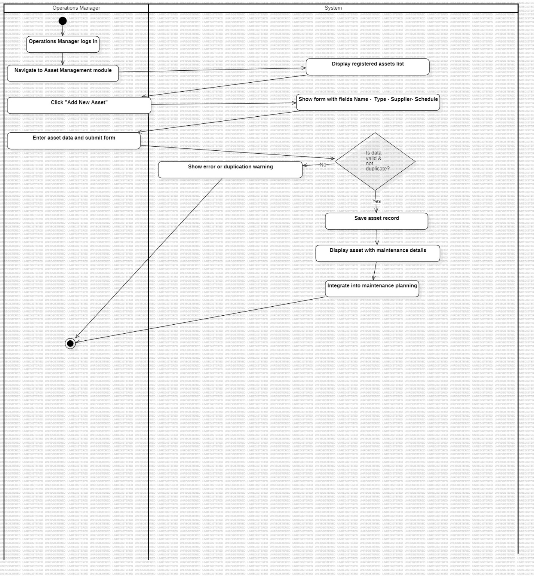

|  |  |
| --- | --- |
| **Name** | **US_27 – Manage Production Process Details (FR_27)** |
| **Summary** | Manufacturer employees can view, update, and track production tasks, including working times, materials used, and job status. |
| **Dependency** | US_02 (User Login) – Manufacturer employee must be logged into the system. |
| **Actors** | Manufacturer Employee (Primary Actor) |
| **Description of the Main Sequence** | * Manufacturer employee logs into the system. * Employee navigates to the “Production Management” section. * The system displays the list of active production tasks and statuses. * Employee selects a task to view detailed information. * The system displays the task details, including: * Timeslot (scheduled working period) * Started working time * Finished working time * Raw materials used (amount and type) * Employee updates the task status and marks milestones as completed (e.g., assembly, packaging). * Employee enters any additional relevant details, such as materials used. * The system records the updates and tracks progress. |
| **Preconditions** | Employee must be authenticated and have access to relevant production tasks.  Production tasks and timeslots must be defined in the system. |
| **Description of the Alternative Sequence** | * If no active tasks are assigned, the system displays: “No production tasks available.” * If an error occurs while updating the status, the system prompts the employee to retry or contact management. |
| **Non-functional Requirements** | The system should allow easy navigation between tasks and job statuses.  All changes must be logged for tracking and auditing purposes. |
| **Post Conditions** | The production process is updated with the latest task status, working time, and material usage. This information is used for performance tracking, reporting, and operational analysis. |

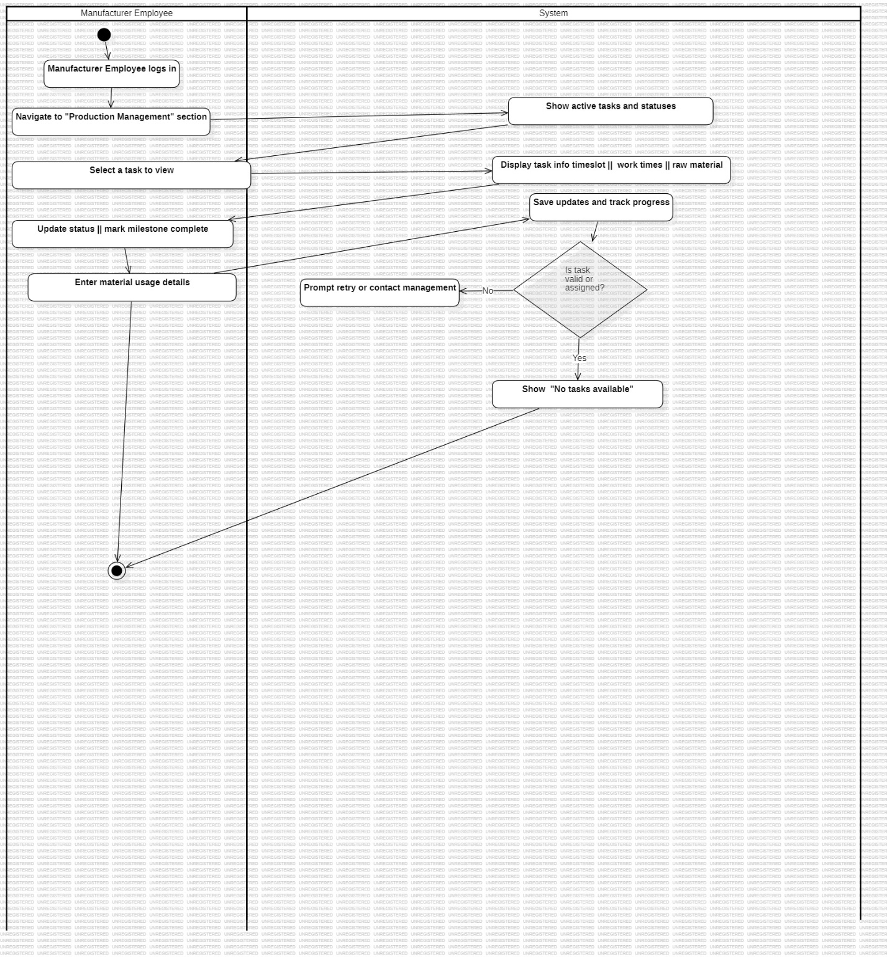

|  |  |
| --- | --- |
| **Name** | **US_28 – Report Broken or Malfunctioning Equipment (FR_28)** |
| **Summary** | Manufacturer employees can report broken or malfunctioning equipment via the system to improve repair response time and prevent work interruptions. |
| **Dependency** | US_02 (User Login) – Manufacturer employee must be logged in to report equipment issues. |
| **Actors** | Manufacturer Employee (Primary Actor) |
| **Description of the Main Sequence** | * Manufacturer employee logs into the system. * Employee navigates to the “Equipment Management” or “Maintenance” section. * The system displays a list of active equipment, including their current status. * Employee selects the equipment that is malfunctioning or broken. * The system prompts the employee to report the issue. * Employee provides a description of the malfunction and selects the severity (e.g., minor, critical). * Employee submits the report. * The system records the issue, updates the equipment status, and notifies the maintenance team for action. |
| **Preconditions** | The equipment must be registered in the system.  Employee must have permission to report equipment issues. |
| **Description of the Alternative Sequence** | * If the equipment is not listed in the system, the employee is prompted to create a new equipment entry. * If the report is incomplete (missing description or severity), the system prompts for the necessary information. |
| **Non-functional Requirements** | * The issue report should be submitted in ≤ 2 seconds. * All reported issues must be logged and timestamped. * The system should provide an option for employees to track the status of reported issues. |
| **Post Conditions** | The equipment malfunction is recorded, and the maintenance team is notified for timely repair or follow-up actions. |

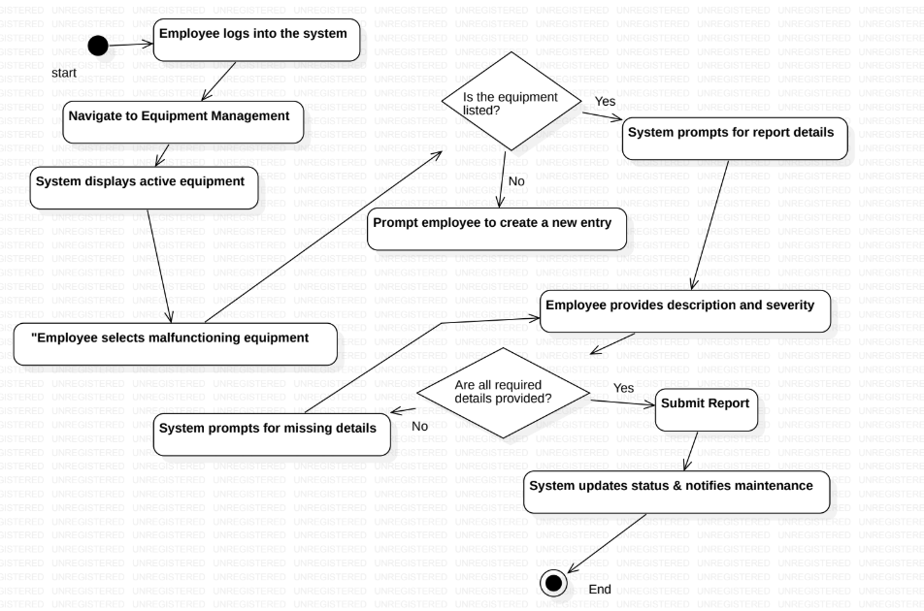

|  |  |
| --- | --- |
| **Name** | **US_29 – Submit Material Shortage Requests (FR_29)** |
| **Summary** | Manufacturer employees can quickly request additional materials when the supply runs low during production to avoid production downtime. |
| **Dependency** | US_02 (User Login) – Manufacturer employee must be logged into the system. |
| **Actors** | Manufacturer Employee (Primary Actor) |
| **Description of the Main Sequence** | * Manufacturer employee logs into the system. * Employee navigates to the “Material Request” section. * The system displays the list of materials currently in use for production. * Employee selects the material that is running low or has run out. * The system prompts the employee to enter the quantity needed and an optional note explaining the request (e.g., urgency). * Employee submits the request for additional material. * The system logs the material shortage request and notifies the relevant inventory or supply chain personnel. |
| **Preconditions** | Materials used in production must already be registered in the system.  Employee must have access to submit material requests. |
| **Description of the Alternative Sequence** | * If the material is not listed in the system, the employee is prompted to add the missing material details or contact inventory management. * If the requested quantity exceeds available inventory or budget limits, the system displays a warning and prompts the employee to adjust the request. |
| **Non-functional Requirements** | All requests must be logged and time-stamped for tracking.  The system should notify the employee when the request is successfully submitted. |
| **Post Conditions** | The material shortage request is successfully recorded, and the relevant personnel are notified for quick action to prevent production delays. |

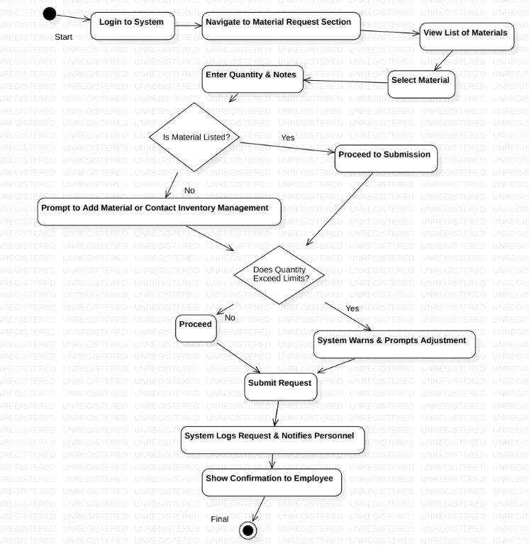

|  |  |
| --- | --- |
| **Name** | **US_30 – Post Employee Work Achievements (FR_30)** |
| **Summary** | The Operations Manager posts all work done by employees in the system to track production achievements. |
| **Dependency** | US_02 (User Login) – Operations Manager must be logged into the system. |
| **Actors** | Operations Manager (Primary Actor) |
| **Description of the Main Sequence** | * Operations Manager logs into the system. * Operations Manager navigates to the “Employee Work Achievements” section. * The system displays a list of employees and their production tasks. * Operations Manager selects a specific employee or task to post work achievements. * The system prompts the Operations Manager to enter achievement details, including: * Task completion status * Work hours completed * Output produced (e.g., units, products) * Operations Manager submits the achievement details. * The system records the work achievements in the system and updates the employee's record. * A confirmation message is displayed. |
| **Preconditions** | The employee's work task must already be logged in the system.  The Operations Manager must have appropriate permissions to update employee achievements. |
| **Description of the Alternative Sequence** | 1.If no tasks or employee data is available, the system will display: “No data available for posting work achievements.”  2.If the input data is incomplete or invalid, the system will prompt for corrections before submission. |
| **Non-functional Requirements** | Data must be logged for audit purposes and timestamped.  The system must ensure secure and accurate updates. |
| **Post Conditions** | The employee's work achievements are recorded and reflected in the system for future tracking and reporting. |

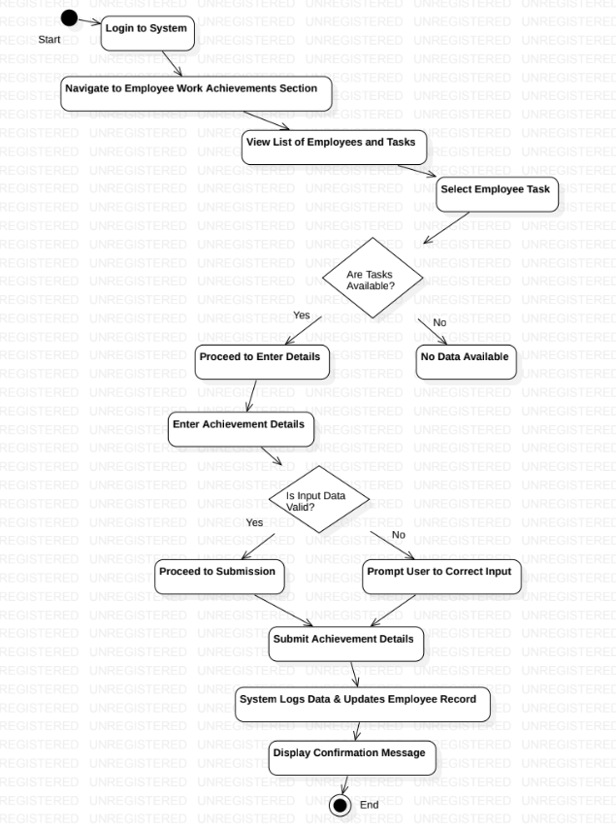

|  |  |  |
| --- | --- | --- |
| **Name** | **US_31 – Add and Update Department**   |  | | --- | |  | |
| **Summary** | HR Manager can add new departments and update existing ones by filling out the department form. |
| **Dependency** | US_02 |
| **Actors** | |  | | --- | |  |   HR Manager(primary actor) |
| **Description of**  **the Main**  **Sequence** | • HR Manager logs into the system.  • HR Manager navigates to the “Department Management” section.  • HR Manager can choose one of the following actions:  a. **Add New Department**   - Selects the “Add New Department” option.   - The system displays a form for entering new department details:    • Department Name    • Department Status    • Department ID   - HR Manager fills in the form and submits it.   - The system validates the data and adds the department to the database.   - A confirmation message is displayed.  b. **Update Existing Department**   - Selects an existing department from the department list.   - The system displays the department details in an editable form.   - HR Manager updates the necessary information (e.g., department name, status, or ID).   - The system validates and saves the updated details.   - A confirmation message is displayed. |
| **Preconditions** | • HR Manager must be logged into the system. • Department details must be provided (for adding or updating). |
| **Description of**  **the Alternative**  **Sequence** | If the department ID already exists during the addition process, the system prompts HR Manager to select a unique ID.  If any required fields are missing or invalid during the update process, the system alerts HR Manager and prompts for corrections. |
| **Non functional**  **requirements** | Data integrity must be maintained, with no duplicate IDs allowed. |
| **Post Conditions** | The department is either successfully added to the system or updated with the new details. HR Manager can proceed with further actions like assigning employees to the department. |

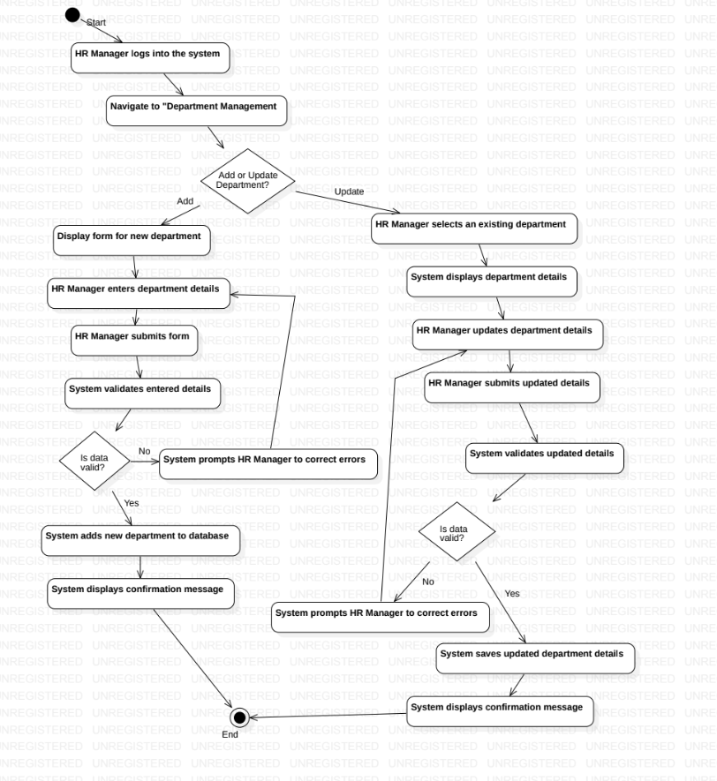

|  |  |
| --- | --- |
| **Name** | **US_32 – Add Work Instructions** |
| **Summary** | The Operation Manager enters details about work instructions, including machine hours used. |
| **Dependency** | US_02 |
| **Actors** | Operation Manager (Primary Actor) |
| **Description of**  **the Main**  **Sequence** | 1. Operation Manager logs into the system.  2. Operation Manager selects the “Add Work Instructions” option.  3. The system displays a form for entering work instructions.  4. Operation Manager enters the details about the work instructions, including:  • Machine hour used  • Task description  • Any special instructions or safety notes  5. Operation Manager submits the form.  6. The system validates the input data and saves it in the database.  7. A confirmation message is displayed, and the work instructions are recorded. |
| **Preconditions** | • Operation Manager must be logged into the system.  • The necessary machine and task details must be available. |
| **Description of**  **the Alternative**  **Sequence** | If any required fields are missing or invalid, the system alerts the Operation Manager and prompts for corrections. |
| **Non functional**  **requirements** | All work instructions must be stored securely and be easily retrievable for future reference. |
| **Post Conditions** | The work instructions are successfully added to the system, and the Operation Manager can proceed with other tasks. |

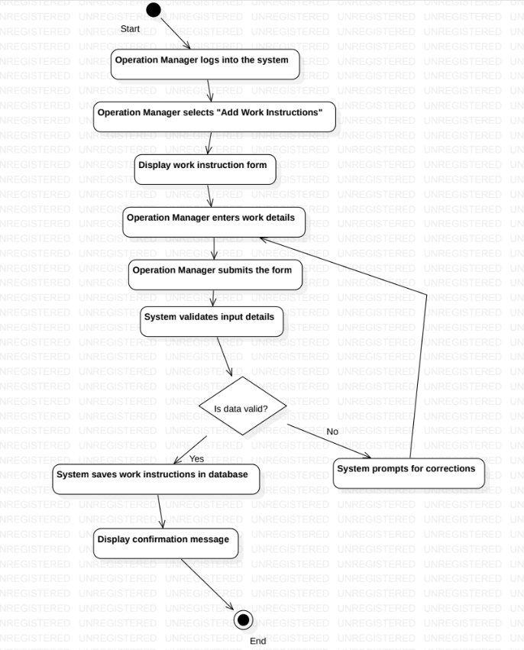

# System Design/Diagrams

# 

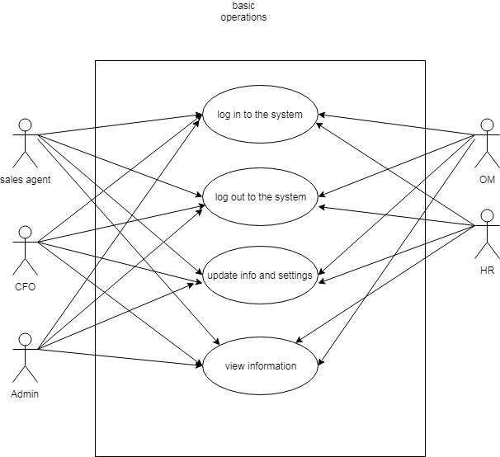

***5.1Use case diagrams***

BASIC OPERATIONS-US_01,US_02,US_06,US_09,US_12,US_13,US_16,US_19,US_23,US_26,US_28,US_32

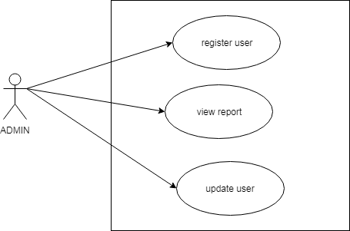 US_01,US_32

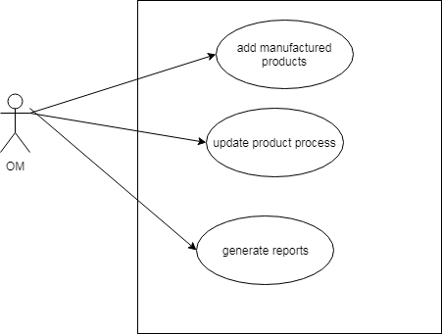



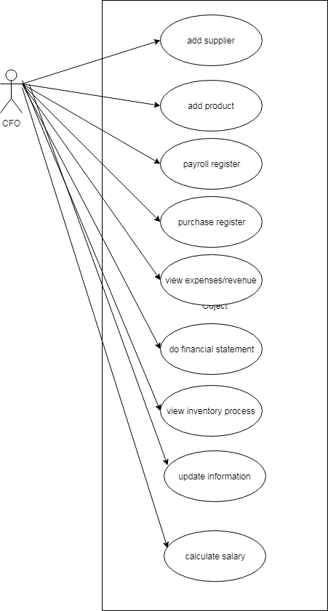

CFO-US_02,US_07,US_09,US_10,US_12,US_13,US_17,US_19,US_20,US_27

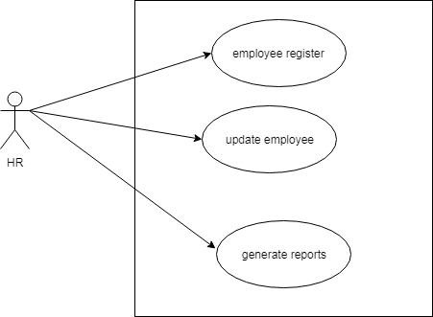

HR-US_01,

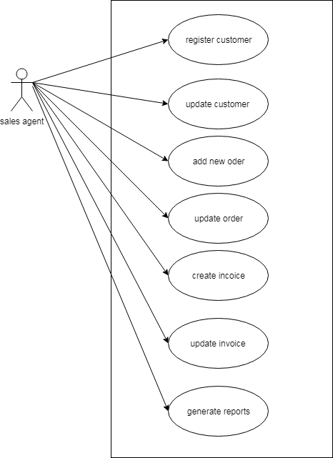

Sales agent-US_04, US_06, US_21, US_23, US_24, US_26, US_29